THE GEISA SPECTROSCOPIC DATABASE SYSTEM REVISITED FOR IASI DIRECT RADIATIVE TRANSFER MODELLING

N. Jacquinet-Husson*, N.A. Scott*, A. Chédin*, and A.A. Chursin**

*Laboratoire de Météorologie Dynamique, Ecole Polytechnique, 91128 Palaiseau, France,
**Institute of Atmospheric Optics, 634021, Tomsk, Russia

e-mail:nicole.jacquinet@lmd.polytechnique.fr, fax: (33-1)-69-33-37-58, phone : (33-1)-69-33-48-02
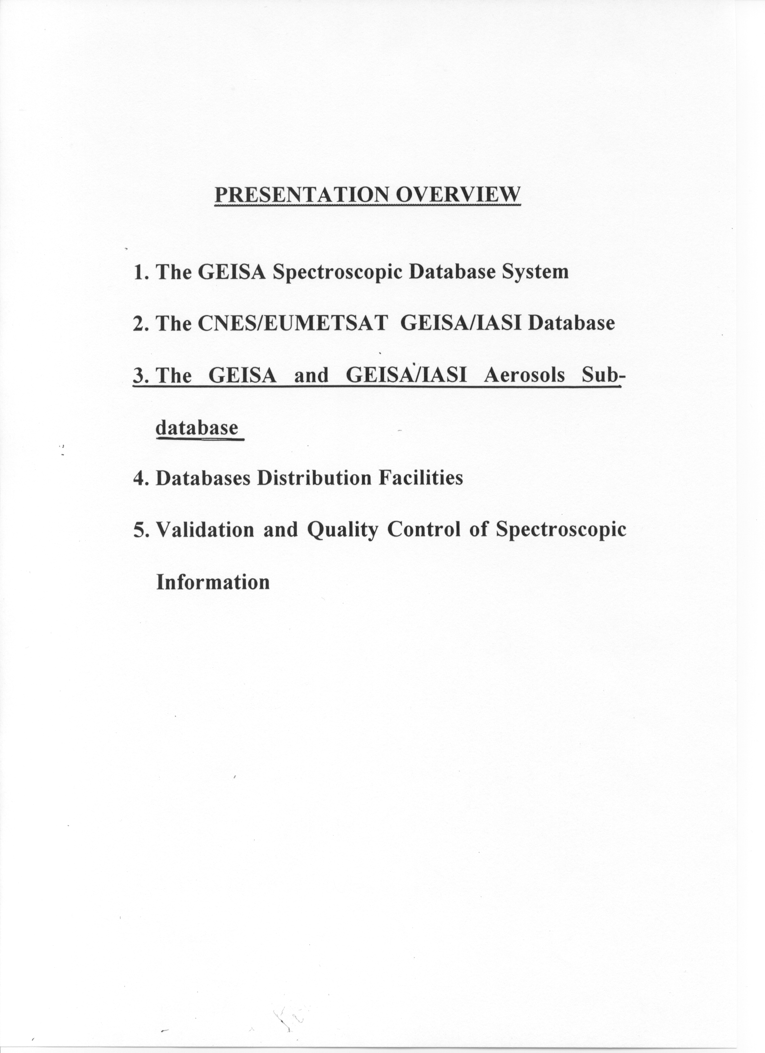

THE GEISA SPECTROSCOPIC DATABASE SYSTEM

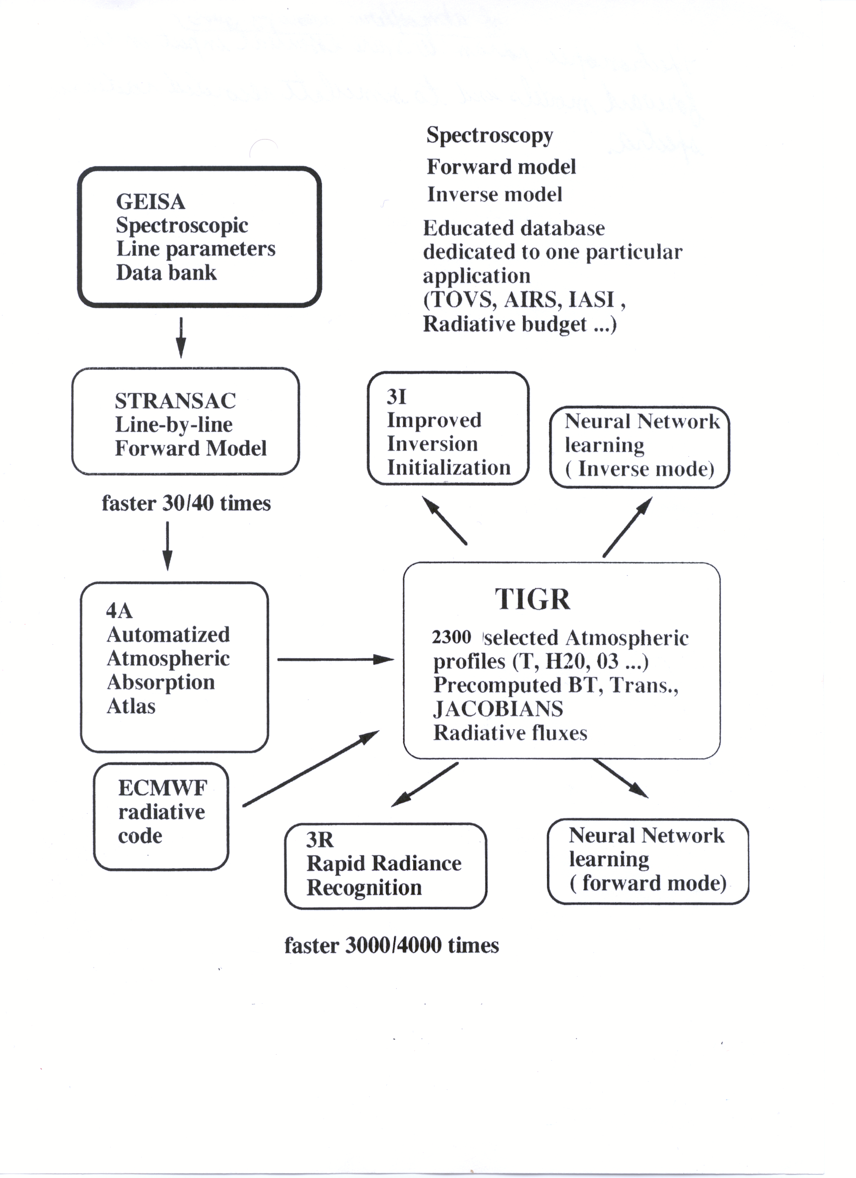
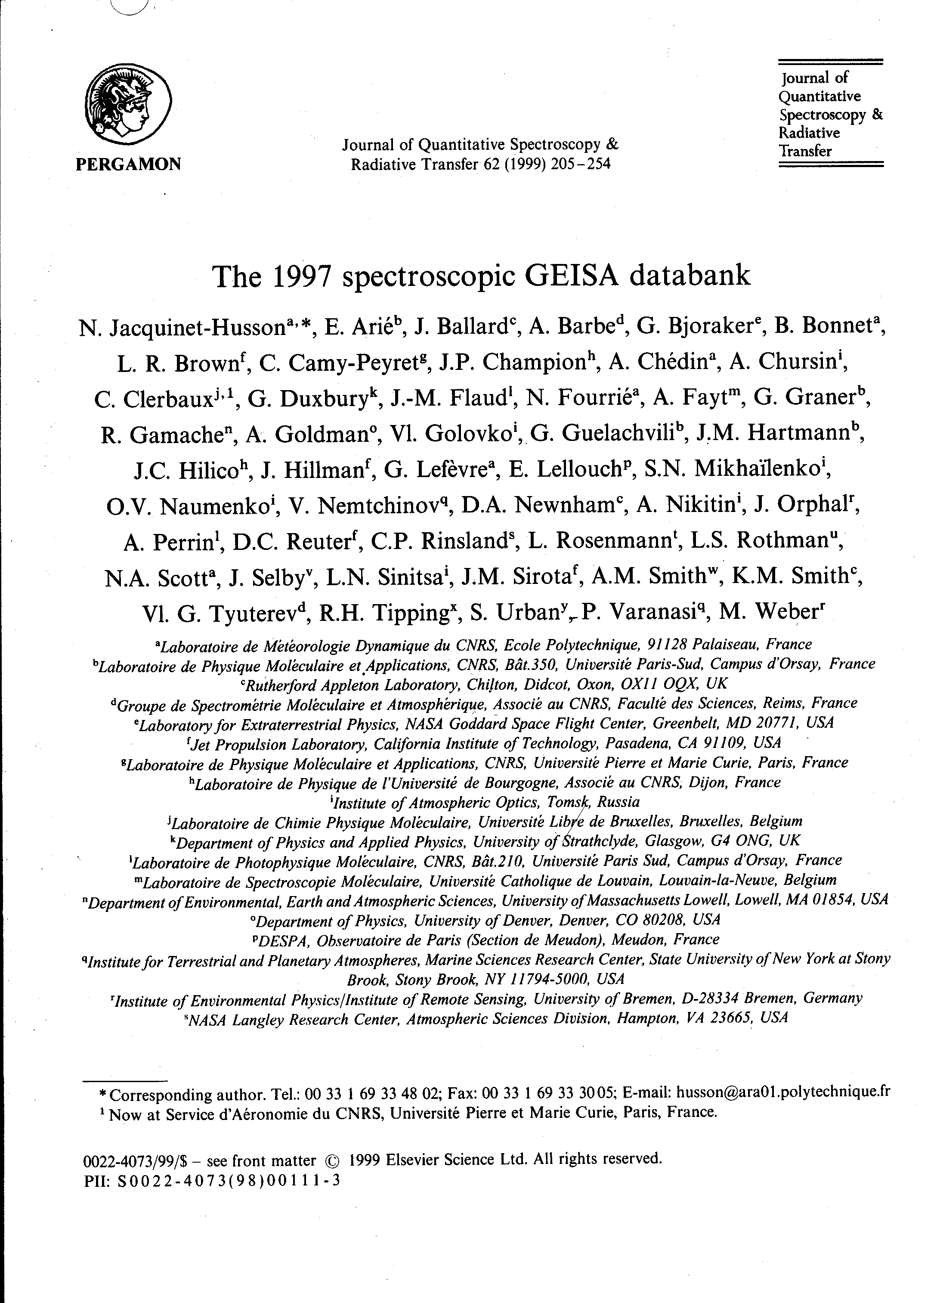

THE GEISA-2002 SYSTEM
Gestion et Etude des Informations Spectroscopiques Atmosphériques ; Management and Study of Atmospheric Spectroscopic Information

Three DATABASES

Individual spectral lines spectroscopic parameters database

42 molecules (96 isotopic species) between 0 and 22,656 cm⁻¹.
1,346,266 entries. between 0 and 22,656 cm⁻¹.
160 Mbytes

Absorption cross-sections database(mainly CFC’s)
23 molecular species
4, 716,743 entries
130 Mbytes

Refractive Indices of Basic Atmospheric aerosol components database

About 20 components

50 Mbytes

ASSOCIATED MANAGEMENT SOFTWARES
(For each database)

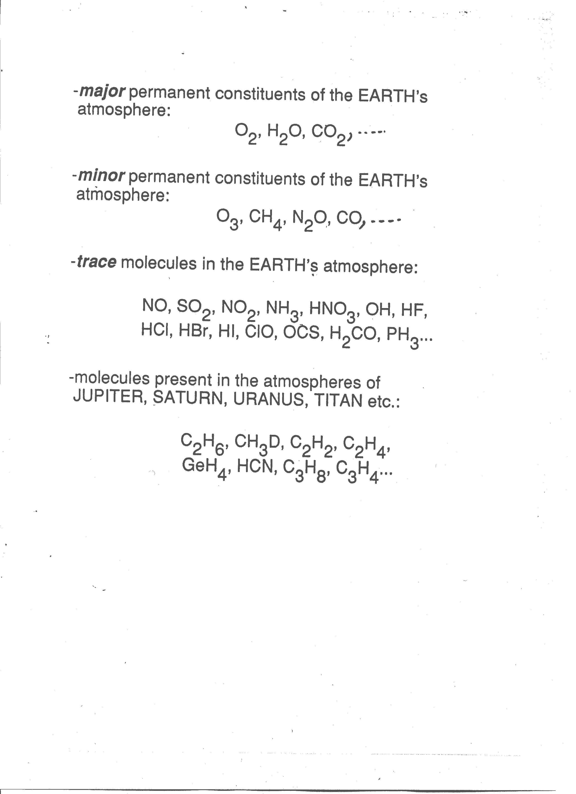

DETAILED CONTENT OF GEISA-97 EDITION

INDIVIDUAL LINES SPECTROSCOPIC DATA CATALOG

Detailed content of GEISA97 edition

Mol. | ID | # Lines | Intensity average | Alpha  average | Iso.  ID | # Lines | F-Min  (cm-1) | F-Max  (cm-1) | Int-Min  (cm molec-1) | Int-Max  (cm molec-1)
H₂O | 1 | 50217 | 1.450E-21 | 0.069 | 161  162  171  181  182 | 30117  9799  3744  6357  200 | 0.401  0.007  6.471  6.785  1231.680 | 22656.465  5507.548  11150.790  13900.421  1607.611 | 1.010E-32  1.240E-32  1.490E-27  1.000E-27  1.000E-26 | 2.670E-18  2.700E-22  9.830E-22  5.390E-21  7.940E-26
CO₂ | 2 | 62816 | 1.793E-21 | 0.071 | 626  636  628  627  638  637  828  728  838 | 27896  9154  13554  6625  2312  1584  1107  288  296 | 442.006  497.201  507.860  554.909  567.596  584.754  615.974  626.438  2115.685 | 9648.007  8104.666  8132.007  6961.226  4946.384  3641.072  3669.609  2358.226  2276.481 | 0.000E+00 (§)  0.000E+00 (§)  1.390E-36  1.000E-27  3.700E-27  3.710E-27  1.760E-40  3.870E-27  4.870E-42 | 3.520E-18  3.570E-20  6.850E-21  1.280E-21  7.230E-23  1.360E-23  1.310E-23  2.500E-24  1.760E-25
O₃ | 3 | 281607 | 6.533E-23 | 0.069 | 666  668  686  667  676 | 167755  19147  7513  58254  28938 | 0.026  0.921  1.177  0.289  0.213 | 4060.783  1177.493  1145.690  820.380  822.795 | 4.060E-29  4.880E-28  7.500E-28  5.340E-31  1.490E-31 | 4.200E-20  7.760E-23  7.560E-23  5.570E-25  6.060E-25
N₂O | 4 | 26771 | 2.688E-21 | 0.075 | 446  447  448  456  546 | 19423  1004  2034  2128  2182 | 0.838  542.242  545.179  5.028  4.858 | 5131.249  3482.917  3463.967  3462.689  3473.528 | 4.000E-27  3.430E-26  1.230E-25  5.220E-26  4.720E-26 | 1.000E-18  4.150E-22  2.050E-21  3.670E-21  3.600E-21
CO | 5 | 13515 | 7.545E-22 | 0.047 | 26  27  28  36  38  37 | 5908  748  770  4768  741  580 | 3.530  3.714  3.629  3.414  3.462  1807.871 | 8464.883  6338.061  6266.578  8180.219  6123.294  6196.551 | 7.880E-78  8.190E-40  7.610E-39  3.610E-73  2.580E-40  1.030E-36 | 4.460E-19  1.600E-22  8.320E-22  4.680E-21  8.700E-24  1.680E-24
CH₄ | 6 | 66883 | 2.622E-22 | 0.052 | 211  311 | 56989  9894 | 0.010  0.032 | 6184.492  6069.086 | 4.060E-34  4.100E-34 | 2.062E-19  2.329E-21
O₂ | 7 | 6292 | 4.117E-26 | 0.044 | 66  67  68 | 1435  4186  671 | 0.000  0.000  1.572 | 15927.806  14536.515  15851.213 | 0.000E+00 (§)  1.147E-47  1.186E-35 | 8.833E-24  5.337E-26  1.710E-26
NO | 8 | 94738 | 4.989E-23 | 0.053 | 46  48  56 | 93360  679  699 | 0.000  1601.909  1609.585 | 9273.214  2038.846  2060.462 | 1.401E-85  4.190E-28  4.430E-28 | 6.211E-20  1.390E-22  2.550E-22
SO₂ | 9 | 38853 | 1.065E-21 | 0.114 | 626  646 | 38566  287 | 0.017  2463.470 | 4092.948  2496.088 | 1.020E-28  9.740E-24 | 6.090E-20  3.430E-23
NO₂ | 10 | 100680 | 6.194E-22 | 0.067 | 646 | 100680 | 0.498 | 2938.381 | 4.240E-28 | 1.300E-19
NH₃ | 11 | 11152 | 4.275E-21 | 0.077 | 411  511 | 10062  1090 | 0.215  0.375 | 5294.501  5179.786 | 2.970E-29  5.460E-29 | 5.450E-19  1.990E-21
PH₃ | 12 | 4635 | 6.457E-21 | 0.075 | 131 | 4635 | 17.805 | 2445.553 | 3.690E-28 | 2.930E-19
HNO₃ | 13 | 171504 | 6.879E-22 | 0.105 | 146 | 171504 | 0.035 | 1769.982 | 3.490E-27 | 3.020E-20
OH | 14 | 41786 | 1.048E-21 | 0.044 | 61  62  81 | 41631  90  65 | 0.005  0.010  0.053 | 19267.869  1.824  6.325 | 1.401E-85  2.090E-31  1.200E-30 | 3.458E-18  5.780E-29  1.200E-26
HF | 15 | 107 | 6.772E-19 | 0.041 | 19 | 107 | 41.111 | 11535.570 | 1.100E-26 | 1.440E-17
HCl | 16 | 533 | 3.189E-20 | 0.040 | 15  17 | 284  249 | 20.270  20.240 | 13457.841  10994.721 | 1.090E-26  1.010E-26 | 5.030E-19  1.610E-19

Detailed content of GEISA97 edition (contd.)

Mol. | ID | # Lines | Intensity average | Alpha  average | Iso.  ID | # Lines | F-Min  (cm-1) | F-Max  (cm-1) | Int-Min  (cm molec-1) | Int-Max  (cm molec-1)
HBr | 17 | 576 | 1.072E-20 | 0.051 | 19  11 | 289  287 | 16.237  16.232 | 9758.564  9757.189 | 1.000E-26  1.010E-26 | 1.210E-19  1.180E-19
HI | 18 | 237 | 4.623E-21 | 0.050 | 17 | 237 | 12.509 | 8487.305 | 1.020E-26 | 1.540E-19
ClO | 19 | 7230 | 1.605E-22 | 0.087 | 56  76 | 3599  3631 | 0.028  0.015 | 1207.639  1199.840 | 1.520E-29  5.090E-30 | 3.240E-21  1.030E-21
OCS | 20 | 24922 | 4.251E-21 | 0.090 | 622  624  632  623  822  634 | 14500  4764  2403  1802  1096  357 | 0.406  0.396  0.404  509.007  0.381  1972.188 | 4118.004  4115.931  4012.468  4115.588  4041.565  2910.543 | 1.560E-25  6.400E-27  1.720E-27  1.010E-23  2.620E-28  1.010E-23 | 8.550E-20  4.720E-20  1.200E-20  8.430E-21  2.090E-21  5.240E-22
H₂CO | 21 | 2702 | 8.610E-21 | 0.120 | 126  128  136 | 1772  367  563 | 0.000  0.035  0.037 | 2998.527  47.486  75.745 | 1.020E-38  1.160E-30  2.020E-30 | 7.500E-20  1.110E-22  6.290E-22
C₂H₆ | 22 | 14981 | 2.686E-22 | 0.101 | 226  236 | 8944  6037 | 765.027  725.603 | 3000.486  918.717 | 5.800E-27  1.320E-28 | 3.210E-20  1.770E-23
CH₃D | 23 | 11524 | 9.333E-25 | 0.060 | 212 | 11524 | 7.760 | 3146.460 | 5.570E-30 | 4.030E-22
C₂H₂ | 24 | 1668 | 2.340E-20 | 0.061 | 211  231 | 1432  236 | 604.774  613.536 | 3358.285  3374.223 | 1.370E-27  3.820E-26 | 1.080E-18  1.580E-20
C₂H₄ | 25 | 12978 | 1.411E-21 | 0.087 | 211  311 | 12967  281 | 701.203  2947.832 | 3242.172  3180.238 | 6.940E-26  5.060E-24 | 8.410E-20  1.620E-21
GeH₄ | 26 | 824 | 4.978E-20 | 0.100 | 824 | 804 | 1937.371 | 2224.570 | 1.960E-22 | 3.680E-19
HCN | 27 | 2575 | 1.205E-20 | 0.132 | 124  125  134 | 2275  115  185 | 2.956  2.870  2.880 | 18407.973  9671.953  9627.961 | 1.780E-28  5.110E-26  4.150E-26 | 7.100E-19  2.730E-21  8.290E-21
C₃H₈ | 28 | 9019 | 4.168E-23 | 0.080 | 221 | 9019 | 700.015 | 799.930 | 3.770E-24 | 4.310E-22
C₂N₂ | 29 | 2577 | 2.668E-21 | 0.080 | 224 | 2577 | 203.955 | 2181.690 | 6.590E-24 | 2.580E-20
C₄H₂ | 30 | 1405 | 3.445E-21 | 0.100 | 211 | 1405 | 190.588 | 654.425 | 2.650E-24 | 6.930E-20
HC₃N | 31 | 2027 | 2.693E-21 | 0.100 | 124 | 2027 | 474.293 | 690.860 | 6.360E-24 | 4.420E-20
HOCl | 32 | 15565 | 2.295E-21 | 0.060 | 165  167 | 8057  7508 | 0.024  0.349 | 3799.249  3799.682 | 1.650E-27  7.220E-28 | 3.590E-20  1.140E-20
N₂ | 33 | 117 | 5.729E-29 | 0.047 | 44 | 117 | 2001.711 | 2619.230 | 2.330E-34 | 3.410E-28
CH₃Cl | 34 | 9355 | 5.584E-22 | 0.085 | 215  217 | 5311  4044 | 679.050  674.143 | 3172.927  3161.830 | 1.250E-25  4.190E-26 | 1.130E-20  3.540E-21
H₂O₂ | 35 | 100781 | 5.090E-22 | 0.107 | 166 | 100781 | 0.043 | 1499.487 | 5.090E-29 | 5.610E-20
H₂S | 36 | 20788 | 2.992E-22 | 0.136 | 121  131  141 | 12330  3564  4894 | 2.985  5.601  5.615 | 4256.547  4098.234  4171.176 | 1.450E-26  2.020E-26  2.020E-26 | 1.360E-19  5.990E-21  1.080E-21
HCOOH | 37 | 3388 | 5.186E-21 | 0.400 | 261 | 3388 | 1060.962 | 1161.251 | 2.140E-22 | 2.840E-20
COF₂ | 38 | 54866 | 2.178E-21 | 0.084 | 269 | 54866 | 725.005 | 1981.273 | 4.740E-24 | 3.830E-20
SF₆ | 39 | 11520 | 4.551E-21 | 0.050 | 236 | 11520 | 940.425 | 952.238 | 2.160E-22 | 1.500E-20
C₃H₄ | 40 | 3390 | 4.277E-22 | (*) | 341 | 3390 | 290.274 | 359.995 | 2.020E-23 | 3.180E-21
HO₂ | 41 | 26963 | 9.907E-22 | 0.088 | 166 | 26963 | 0.055 | 3675.819 | 3.550E-27 | 2.900E-20
ClONO₂ | 42 | 32199 | 1.093E-22 | 0.140 | 564  764 | 21988  10211 | 763.641  765.212 | 797.741  790.805 | 1.250E-24  6.340E-25 | 3.850E-22  1.260E-22
TOTAL LINES IN GEISA 1997: 1,346,266
Underlined molecules are new or updated for GEISA97

(*) missing value set to 0.000
(§) minimum intensity value corresponding to extremely weak line
Fields of the format for each transition in the GEISA database

Fortran Format  Descriptor | F12.6 | D11.4 | F6.4 | F10.4 | A36 | F4.2 | I3 | I3 | A1 | I2 | I1 | E10.3 | F5.4 | F8.6 | I3 | I6 | 120  characters
C % Format Descriptor | 12.6f | 10.3e | 6.4f | 10.4f | .36s | 4.2f | 3i | 3i | .1s | 2i | 1i | 10.3e | 5.4f | 8.6f | 3i | 6i
Fortran Variable Type¹ | R*8 | R*8 | R*4 | R*4 | C*36 | R*4 | I*2 | I*2 | C*1 | I*2 | I*2 | R*4 | R*4 | R*4 | I*2 | I*4 | 100 bytes
Field Name⁴⁻⁵ | A | B | C | D | E | F | G | I | J | K | L | M | N | O | P | Q | 16 fields

The R, I, C symbols are abbreviations for the conventional Real, Integer and Character Fortran type declarators
⁽²⁾ The F, D, I, C symbols are abbreviations for the standard float, double, integer and char C type declarators.
⁽³⁾ Real type values (Fortran R* or C F, D) are stored in IEEE format,
Character strings (E and J fields) are blank right justified (no ending null character).
⁽⁴⁾ The A-J fields are those used in the GEISA software:
(A) Wavenumber (cm⁻¹) of the line associated with the vibro-rotational transition.
(B) Intensity of the line (cm molecule⁻¹ at 296K).
(C) Lorentzian collision halfwidth (cm⁻¹ atm⁻¹ at 296K).
(D) Energy of the lower transition level (cm⁻¹).
(E) Transition quantum identifications for the lower and upper levels of the transition, as the following:
TRS1 upper state vibrational identification,
TRS2 lower state vibrational identification,
RN1 upper state rotational identification,
RN2 lower state rotational identification.
Blank fields (spaces) at this place match missing information.
(F) Temperature dependence coefficient n of the halfwidth (value set to 0.75 if n not available)
(G) Identification code for isotope.
(I) Identification code for molecule.
(J) Internal GEISA code for data identification.

Fields of the format for each transition in the GEISA database
(Following)

Fortran Format  Descriptor | F12.6 | D11.4 | F6.4 | F10.4 | A36 | F4.2 | I3 | I3 | A1 | I2 | I1 | E10.3 | F5.4 | F8.6 | I3 | I6 | 120  characters
C % Format Descriptor | 12.6f | 10.3e | 6.4f | 10.4f | .36s | 4.2f | 3i | 3i | .1s | 2i | 1i | 10.3e | 5.4f | 8.6f | 3i | 6i
Fortran Variable Type¹ | R*8 | R*8 | R*4 | R*4 | C*36 | R*4 | I*2 | I*2 | C*1 | I*2 | I*2 | R*4 | R*4 | R*4 | I*2 | I*4 | 100 bytes
Field Name⁴⁻⁵ | A | B | C | D | E | F | G | I | J | K | L | M | N | O | P | Q | 16 fields

⁽⁵⁾ The K-Q fields correspond to information related to the actual transition, in a purpose of possible intercomparaison with the HITRAN database.
These fields, not of prime importance for the GEISA software, contain the following parameters:
(K) Molecule number
(L) Isotope number (1=most abundant, 2=second, etc.).
(M) Transition probability (debye²).
(N) Self-broadened halfwidth (HWHM) (cm⁻¹ atm⁻¹ at 296K).
(O) Air-broadened pressure shift of line transition (cm⁻¹ atm⁻¹).
(P) Accuracy indices for frequency, intensity and halfwidth.
(Q) Indices for lookup of references for frequency, intensity and halfwidth.
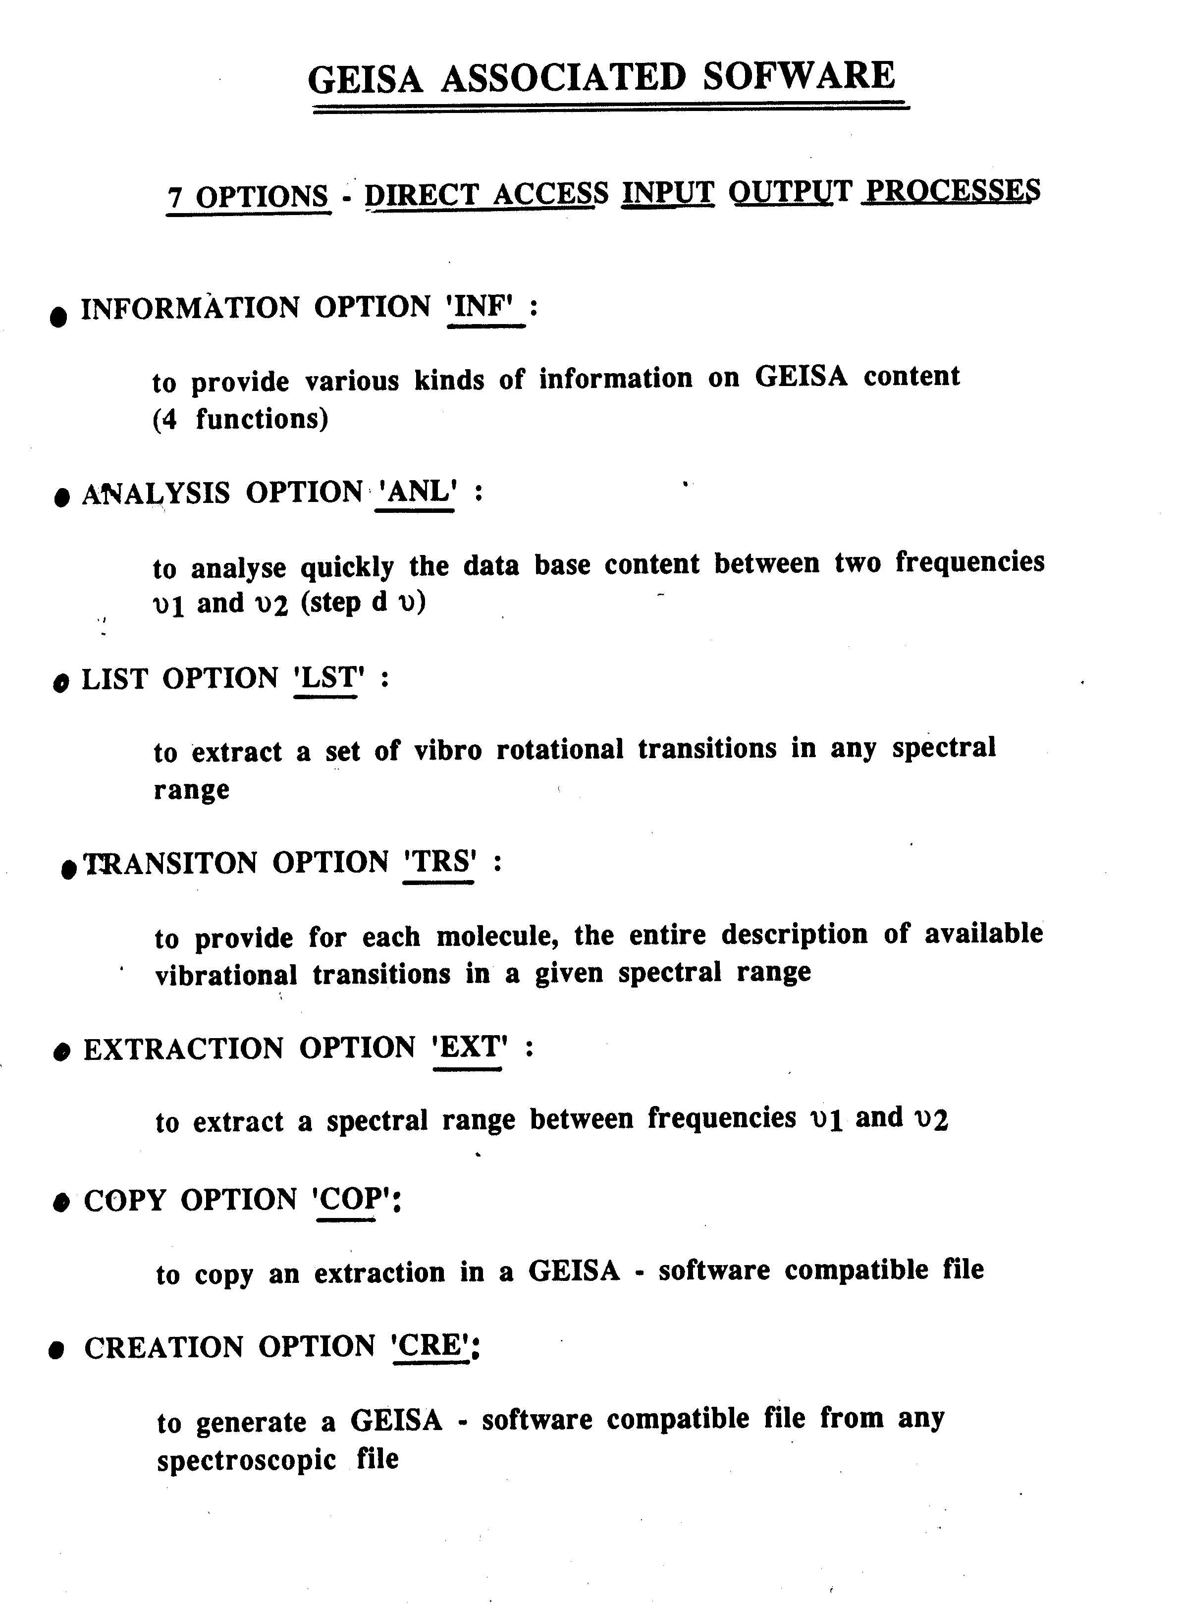

DESCRIPTION OF THE GEISA-97 CROSS-SECTIONS DATABASE

23 MOLECULES 4,716,743 ENTRIES
ASSOCIATED MANAGEMENT SOFTWARE

GEISA97 Database Cross-Sections File and Associated Management Software

Cross-Sections Data
In this file, the spectroscopic parameters related to heavy molecules, like the CFC's, are not stored following the usual standard (i.e. via, line frequency, intensity, half-width, etc.), but principally as absorption cross-sections determined through the following expression:

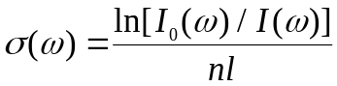
where ω is a frequency (cm⁻¹); σ(ω) is the absorption cross-section (cm² molecule⁻¹); I₀(ω) and I(ω) are the intensities, at the frequency ω, of the incident and transmitted radiation, respectively; n is the concentration of the molecules (molecule cm⁻³) and l the optical path length (cm).
It is the σ(ω) value derived from high-resolution experimental data that is cataloged in the GEISA cross-sections file.
New results on CFC’s cross-sections have been obtained beyond this issue of the database and will be included in the GEISA-2001 issue.

GEISA Cross-Sections Sub-database
Management Program

A data management program is supplied with the GEISA Cross-Section Sub-database.

This program is controlled by an interactive menu allowing the user to extract any part of the cross-sections database.

The outputs can be selected by:
- Molecules
- Wave-numbers
- T and P atmospheric conditions

THE CNES/EUMETSAT GEISA/IASI-2001 DATABASE

GEISA/IASI-2001 database GENERAL CONTEXT

IASI is a spectrometer which measures the spectral distribution of radiation. The instrument’s concept is based on the Michelson interferometer. In addition, it includes an infrared imaging device that allows cloud cartography to be derived in its field of view.
The instrument’s main characteristics were laid down in order to meet the requirements of the atmospheric meteorological mission. In particular, spectral and radiometric resolutions are linked to the requirements of weather forecast centers for highly accurate humidity and temperature profiles.

The GEISA/IASI database is both an extraction (spectral range 600 - 3000 cm⁻¹) and a partial update of the GEISA-97 Spectroscopic Database. It is maintained and developed with the purpose of assessing the IASI measurements capabilities and its own database quality, within the ISSWG in the frame of the CNES/EUMETSAT Polar System EPS, by simulating high resolution radiances and/or using experimental data.

GEISA/IASI-2001 DATABASE OVERALL CONTENTS

- A Sub-database on individual spectral lines of 14 molecules (53 isotopic species):
H₂O, CO₂, O₃, N₂O, CO, CH₄, O₂, NO, SO₂, NO₂, HNO₃, OCS, C₂H₂, N₂.
- A Sub-database on absorption Cross-Sections of 6 molecules:

CFC-11, CFC-12, CFC-14, CCl4, N2O5, HCFC-22.

- A Sub-database on micro-physical and optical properties of atmospheric aerosols (similar with the GEISA-2001 one)

GEISA/IASI-2001 individual spectrAl lines
SUB-DATABASE

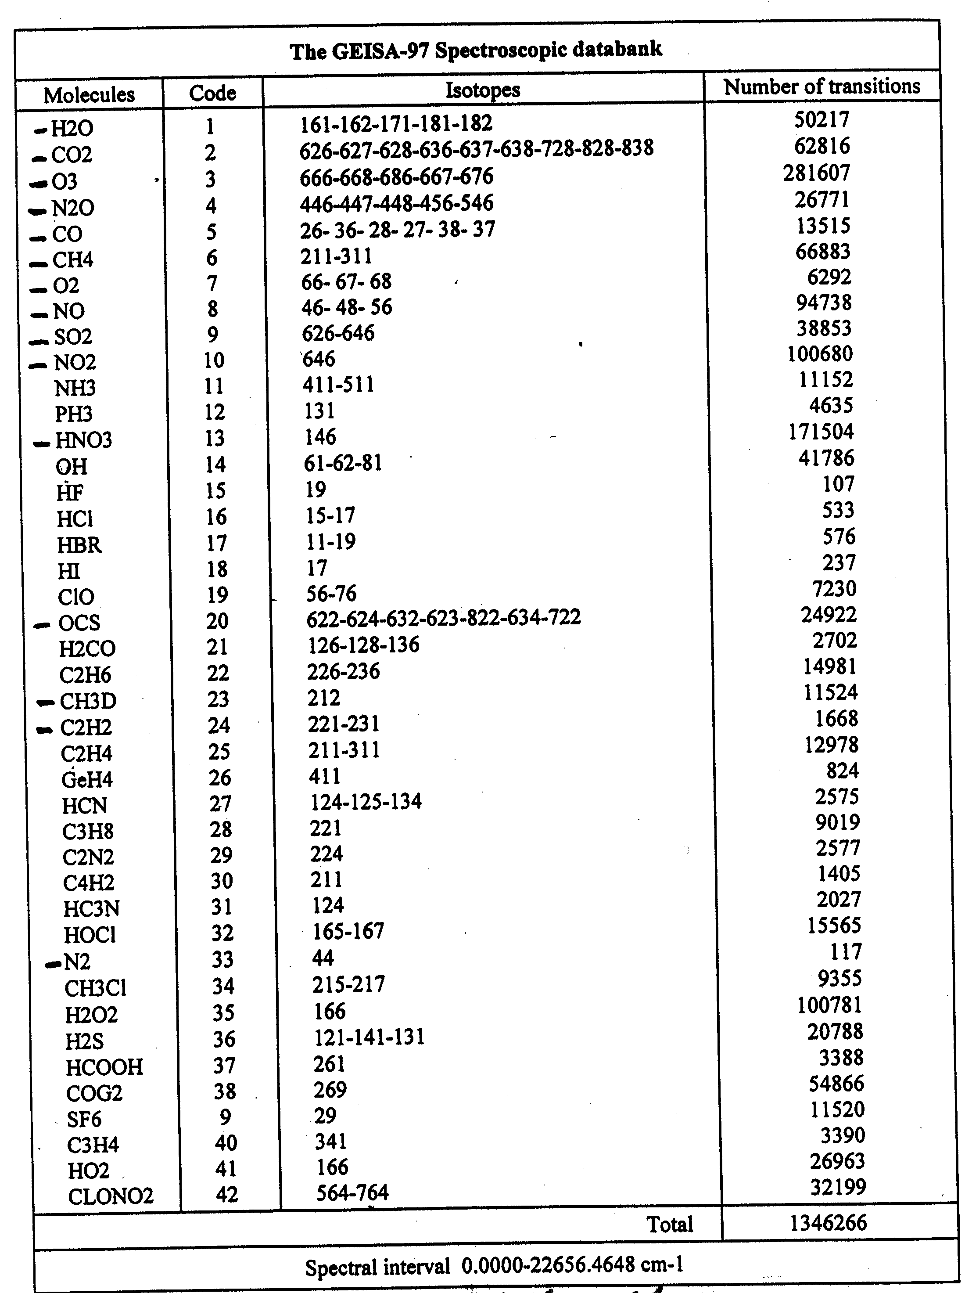

Marked molecular species have been selected for GEISA/IASI archive
(CH3D considered as an isotope of Methane in GEISA/IASI)
GIDSC ( GEISA/IASI DATABASE SCIENTIFIC committee)
proposed new format for the GEISA/IASI line by line sub - database

Format | F12.6 | D11.4 | F6.4 | F10.4 | A36 | F4.2 | I3 | I3 | A1 | I2 | I1 | E10.3 | F5.4 | F8.6 | I3 | I6
Field name | A | B | C | D | E | F | G | I | J | K | L | M | N | O | P | Q

F6.4 | F10.6 | D11.4 | F6.4 | F4.2 | F8.6 | F6.4 | F5.4 | F4.2 | F4.2 | F8.6 | F8.6 | F4.2 | F4.2
R | A' | B' | C' | F' | O' | R' | N' | S | S' | T | T' | U | U'

A: wavenumber (cm⁻¹) of the line
B: intensity of the line in (cm⁻¹/(molecule.cm⁻²) @296K
C: Air broadening pressure halfwidth (HWHM) (cm⁻¹atm⁻¹) @296K
D: Energy of the lower transition level (cm⁻¹)
E: Transition quantum identifications for the lower and upper state of the transition
F: Temperature dependence coefficient n of the air broadening halfwidth
G: Identification code for isotope
I: Identification code for molecule
J: Internal GEISA code for the data identification
K : Molecule number
L: isotope number (1=most abundant, 2= second…etc)
M: Transition probability (in debye²)
N: Self broadening pressure halfwidth (HWHM) (cm⁻¹atm⁻¹) @296K (for water)
O: Air pressure shift of the line transition (cm⁻¹atm⁻¹) @296K
P: Accuracy indices for frequency, intensity and halfwidth
Q: Indices for lookup of references for frequency, intensity and halfwidth
R: temperature dependence coefficient n of the air pressure shift
GIDSC ( GEISA/IASI DATABASE SCIENTIFIC committee)
proposed new format for the GEISA/IASI line by line sub - database
(Following)

Format | F12.6 | D11.4 | F6.4 | F10.4 | A36 | F4.2 | I3 | I3 | A1 | I2 | I1 | E10.3 | F5.4 | F8.6 | I3 | I6
Field name | A | B | C | D | E | F | G | I | J | K | L | M | N | O | P | Q

F6.4 | F10.6 | D11.4 | F6.4 | F4.2 | F8.6 | F6.4 | F5.4 | F4.2 | F4.2 | F8.6 | F8.6 | F4.2 | F4.2
R | A' | B' | C' | F' | O' | R' | N' | S | S' | T | T' | U | U'

A': estimated accuracy (cm-1) on the line position
B': estimated accuracy on the intensity of the line in (cm⁻¹/(molecule.cm⁻²)
C': estimated accuracy on the air collision halfwidth (HWHM) (cm⁻¹atm⁻¹)
F': estimated accuracy on the temperature dependence coefficient n of the air broadening halfwidth
O': estimated accuracy on the air pressure shift of the line transition
(cm⁻¹atm⁻¹) at 296K
R': estimated accuracy on the temperature dependence coefficient n of the air pressure shift
GIDSC ( GEISA/IASI DATABASE SCIENTIFIC committee)
proposed new format for the GEISA/IASI line by line sub - database
(Following)

Format | F12.6 | D11.4 | F6.4 | F10.4 | A36 | F4.2 | I3 | I3 | A1 | I2 | I1 | E10.3 | F5.4 | F8.6 | I3 | I6
Field name | A | B | C | D | E | F | G | I | J | K | L | M | N | O | P | Q

F6.4 | F10.6 | D11.4 | F6.4 | F4.2 | F8.6 | F6.4 | F5.4 | F4.2 | F4.2 | F8.6 | F8.6 | F4.2 | F4.2
R | A' | B' | C' | F' | O' | R' | N' | S | S' | T | T' | U | U'

water spectroscopic parameter specific additional accuracie informations

N': estimated accuracy on the self broadened (HWHM) (cm⁻¹atm⁻¹) at 296K
S: temperature dependence coefficient n of the self broadening halfwidth
S': estimated accuracy on the temperature dependence coefficient n of the self broadening halfwidth
T: self pressure shift of the line transition (cm⁻¹atm⁻¹) at 296K
T': estimated accuracy on the self pressure shift of the line transition (cm⁻¹atm⁻¹) at 296K
U: temperature dependence coefficient n of the self pressure shift
U': estimated accuracy on the temperature dependence coefficient n of the self pressure shift

GEISA/IASI-2001 CROSS-SECTIONS
SUB-DATABASE

Content of GEISA /IASI-2001 Cross-Sections Sub-database.
Molecule id.  Formula | Spectral interval | Temperatures | References
CFC11  CCl₃F | 810 - 880 cm⁻¹  1050 - 1120 cm⁻¹ | 55 temperatures from 190 to 296 K | Li and Varanasi, 1994
CFC12  CCl₂F₂ | 800 - 950 cm⁻¹  1050 - 1200 cm⁻¹ | 52 temperatures from 190 to 296 K | Varanasi  and Nemtchinov, 1994
CFC-14  CF₄ | 1250 - 1290 cm⁻¹ | 55 temperatures from 180 to 296 K | Varanasi et al., 1999a
CCl₄ | 750 - 812 cm⁻¹ | 32 temperatures from 208 to 296 K | Varanasi et al., 1999b
N₂O₅ | 557 – 1763 cm⁻¹ | 4 temperatures from 233 to 293 K | Massie et al., 1985
HCFC-22 | 750 – 870 cm⁻¹  765 – 1380 cm⁻¹ | 8 temperatures  from 216 to 294 K | Varanasi et al., 1994 ;  Clerbaux et al., 1993

THE GEISA AND GEISA/IASI-2001 AEROSOLS SUB-DATABASE

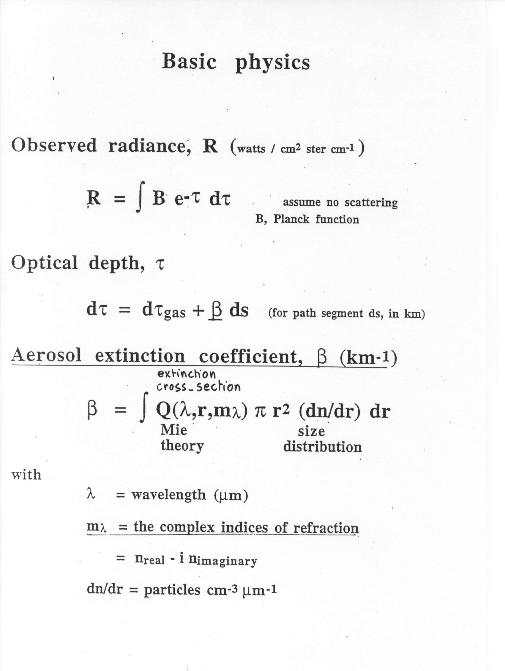
AEROSOL CHARACTERISTICS

Microphysical PROPERTIES

- Size Distribution
- Refractive index
- Shape

OPTICAL PROPERTIES

- Extinction coefficient
- Scattering coefficient
- Absorption coefficient
- Single scattering albedo
- Asymmetry parameter
- Phase function

Mie theory assumed (particles as spheres) for aerosol particles and cloud droplets and ice crystals (in the terrestrial spectral range).

Geometric optics in the case of ice crystals (hexagonal columns in the solar spectral range).

Different size distribution function (Gamma, lognormal, analytical) depending on the nature of aerosols (water clouds, cirrus clouds, ….)

GEISA-2001 Aerosols Sub-Database

GEISA-2001/ Aerosols database contains data on microphysical and optical properties of basic aerosol components.

The following 4 sub-databases are included:

A database on refractive indices of basic atmospheric aerosol components:
- Solid Substances
- Acids
- Water ice
- Water droplets
- Water soluble components
- Thin films
A Database on atmospheric aerosols from LITMS (Rublev, 1994)

The software package and database OPAC (Optical Properties of Aerosols and Clouds) (Hess et al., 1998)

The Global Aerosol Data Set: GADS (Koepke et al., 1997)

ABBREVATIONS

GADS Global Aerosol Data Set (Max-Plank Institut für Meteorologie, Hamburg, Germany)

LITMS Laboratory for Information Technologies and Mathematical Simulation (Kurchatov Institute, Moscow,
Russia)

OPAC Optical Properties of Aerosols and Clouds (Max-Plank Institut für Meteorologie, Hamburg, Germany)

WMO World Meteorological Organization (Geneva, Swizerland)

DATABASES DISTRIBUTION FACILITIES

availability of THE GEISA DATABASE

The current GEISA database is available with its associated management software, freely from the ARA/LMD group workstations web site:

http ://ara01.lmd.polytechnique.fr/registration

with registerme as name and no password required

(over 350 registered users )
Added to this facility, the GEISA97 file as a whole, with related description and general information files, is available from the following anonymous ftp site:
ara01.lmd.polytechnique.fr
in the sub-directories: pub/libgeisa
More complementary information and assistance will be provided upon request at: nj@ara01.lmd.polytechnique.fr.
GEISA/IASI-2001 ftp access

GEISA/IASI-2001 individual lines sub-database ftp access

- All data are on ftp-anonymous at
ara01lmd..polytechnique.fr/pub/geisa/iasi2000

- There are 14 gzipped files *.gz with data for each molecule:
<molecule name>_iasi00.g00.gz,
e.g.:
h2o_iasi00.g00.gz
co2_iasi00.g00.gz
……….
- The whole data base is written in the gs_iasi00.g00.gz file.
- Detailed content of GEISA/IASI-2000 edition is written in gs_iasi00.trs file.

All *.gz files are binary ones! The gs_iasi00.trs file is in ASCII format.
===============================================

GEISA/IASI-2001 cross sections sub-database ftp access
- All data are on ftp-anonymous at
ara01.lmd.polytechnique.fr/pub/geisa/iasi2000/cross

- See README_cross file for more information.
===============================================

GEISA/IASI-2001 aerosols sub-database ftp access
- GEISA_AEROS/IASI-00 data files and management software are available from the anonymous ftp sites at:
ara01.lmd.polytechnique.fr/pub/geisa/iasi/aerosol
ara01.lmd.polytechnique.fr/pub/geisa/iasi/aerosolweb/ftp_aeros.zip

GEISA/IASI-2001 Aerosols

FTP server data files and folders

ftp://ara01.lmd.polytechnique.fr/pub/geisa/iasi/aerosol

Sub-folders of “aerosol”

Folder name | Folder designation
Aerosol  l | Root folder  Refractive indices of basic aerosol constituents(LITMS)
Doc | Documentation files (format Word and Pdf)
Example

Glodat | The GADS data files
opac_calc | Microphysical and optical aerosol models (OPAC)
Optdat | Optical properties of basic aerosol constituents
Prog | Sources of programs (OPAC, GADS, LITMS)
massie2000 | Refractive indices of aerosol constituents (gathered by S. Massie)
Web | GEISA/IASI Web Interface pages (Zip archive file)

VALIDATION AND QUALITY CONTROL OF SPECTROSCOPIC INFORMATION

remaining spectroscopic related problems

Some conclusions of validation exercises, using the 4A-00/LMD Model, in the case of IASI radiative transfer modelling

- The water vapour spectroscopic parameters: still need to be validated;
- The water vapour continuum: more tuning to be done when more situations and situations wit high water vapor content become available;
- the freons bands at 850 and 920 cm⁻¹: refine the temperature dependence;
- O₃ in the 9.6 micron region: the spectroscopic parameters still need to be validated;
- some CO2 – Q branches: further improvement/tuning of the line mixing

ACKNOWLEDGMENTS

to

CNES and EUMETSAT for their Encouragements and Support

