Validation of Atmospheric temperature profiles derived using Neural Network approach from AMSU-A measurements onboard NOAA-15 and NOAA-16 satellites and their applications for tropical cyclone analysis.

By

Devendra Singh, R.C.Bhatia, S.K.Srivastav, S.K.Mukharjee and S.Prasad
Satellite Meteorology Division
India Meteorological Department, New Delhi-10003 INDIA.

ABSTRACT

The new High Resolution Picture Transmission (HRPT) reception system installed recently at India Meteorological Department (IMD),New Delhi is capable of receiving real time data from sensors onboard the NOAA-K,L,M and N series of satellites . In this system , Neural Network approach is used to retrieve the temperature profiles from AMSU-A measurements. The retrieval results are evaluated by computing the bias and root mean square (RMS) difference between retrievals and collocated Radiosonde sounding profiles. The IAPP2.0(International Atovs Processing Package) developed at SSEC, University of Winconsin,USA and ICI3.0(Inversion Coupled Imager) developed at Meteo-France have been installed on SGI Origin-200 at IMD, New Delhi. The comparison among different techniques based on a limited data set for the period of January,2002 show that IAPP and ICI yield better results as compared to neural network for all atmospheric levels over the Indian region.

The AMSU-A measurements are also used for the analysis of two recent tropical cyclones which formed in Arabian sea in the months of May and September,2001. The temperature anomalies were computed using AMSU-A derived temperature profiles with NOAA-16 data. The preliminary results based on the analysis of limited data show that, in both cases the warm core anomalies were located at about 250hPa level. The magnitude of warm core anomalies appear to be positively correlated with the strength of the tropical cyclone. The negative temperature anomalies which were also observed at lower levels, appear to be caused by rainfall contamination of lower AMSU-A channels (4-6). This observation can also provide useful information about the location and the intensity of precipitation. The AMSU-A data appear to offer substantial opportunities for improvements in tropical cyclone analysis.

1. Introduction

Information of temperature and moisture distribution in the vertical atmosphere is useful in Aviation meteorology, synoptic forecasting and numerical modeling, Radiosonde instruments provide sounding information over limited land areas, while vast oceanic areas are void of this data. Further the conventional Radiosonde data has inherent problems of solar radiation during day, inaccuracies in measuring the pressures and lags in the sensors. Differences in sounding instruments and computing procedures used by various weather services make inter-comparison further difficult.
The Advanced Microwave Sounding Unit (AMSU), with a total of 20 channels in microwave bands, represents a dramatic improvement in microwave technology over the Microwave Sounding Unit (MSU) onboard earlier satellites of series carrying the TRIOS-N satellites Operational Vertical Sounder (TOVS) (Smith et.al.,1979). The advanced TOVS (ATVOS) which is comprised of AMSU and HIRS/3, are flying on the National Oceanic and Atmospheric Administration (NOAA) polar orbiting satellite (NOAA-15 and 16). Two separate radiometers (AMSU-A and AMSU-B) comprise the AMSU platform. For first time profiling of atmospheric temperature and moisture under all weather condition is possible using AMSU. Another instrument of ATVOS is the High Resolution Infrared Radiation Sounder (HIRS/3) which is very similar to the HIRS/2 of TOVS (Smith et al., 1979). Data from this instrument are used in conjunction with the AMSU instruments to calculate the atmosphere’s vertical temperature profile from the earth’s surface to about 40km altitude. The data is also used to determine ocean surface temperature, total atmospheric ozone levels, perceptible water, cloud height , cloud coverage and surface radiance.

In the present study, an attempt has been made for the validation of temperature profiles using Radiosonde profile data. The temperature profiles are retrieved using different schemes and without using surface and profile guess in the present study. The statistical errors like bias and rmse of temperature profiles retrieved using Neural Network, IAPP and ICI have been compared for NOAA16 data for the month of January,2002 over the tropical Indian region in order to judge that which retrieval scheme gives best quality of end products.

2. Operational Retrieval Schemes

The newly installed HRPT system at IMD, New Delhi retrievs the temperature and moisture profiles operationally using Neural Network Scheme using NOAA15 and NOAA16 data. Recently, we have received the IAPPV2.0 software package from SSEC, University of Wisconsin. The IAPP package is installed and interfaced with AAPP3.0 received from Eumetsat at SGI Origin 200 computer work station. We have also installed the ICI3.0 and interfaced with AAPP3.0 received from Eumetsat.

In general, a neural network is a computer model composed of individual processing elements called neurons. The neurons are connected by links in terms of weights. A neural network may consist of multiple layers of neurons interconnected with other neurons in the different layers. These lavers are referred to as input layer, hidden layer, or output layer. The inputs and the interconnection weights are processed by a wighted summation function to produce a sum that is passed to a transfer function. The output of the transfer function is the output of the neurons. A neural network is trained with input and output pattern examples. It then constructs a nonlinear numerical model of a physical process in terms of network parameters.

The ICI software is interfaced with AAPP (Klaes, 1997) output level-1d files. The main data of AAPP output files are located, calibrated and mapped (MSU/AMSU on HIRS grid) observations. The three pieces of information of AAPP files resulting from the AVHRR cloud mask are used in ICI : mean clear cover in HIRS fov, skin surface temperature (AVHRR split-window), the forecast air surface temperature (on land) or a SST climatology when the situation is cloudy. Two information items extracted from the AMSU pre-processes are also considered : a type of surface in terms of μ-waves and a clear/ cloudy/ precipitating flag. For ATOVS, the cloud class depends on the AVHRR cloud mask but also on the AMSU preprocessing results. The cloud clearing stage is not applied for ATOVS : cloudy and partly-cloudy situations are treated in terms of IR in the same way.

The IAPP currently uses radiances from HIRS/3 and AMSU –A, preprocessed into the AAPP 1-D format, for retrieval. Ancillary data inputs for retrieval are high resolution topography (supplied), surface observations and numerical model data . The IAPP performs temperature and moisture retrieval calculation on a 3x3 HIRS field of view (fov) matrix. HIRS and AMSU –A radiances are used for cloud / clear fov determination. Depending on clouds, a HIRS+AMSU –A retrieval, a AMSU –A only retrieval, or no retrieval is made for each 3x3 fov matrix. If surface observations are not available, numerical model data is used to define surface conditions, or, with neither available, window channel radiances are used to best approximate surface conditions. Numerical model output can be used as a first guess field for the atmosphere and surface.

3. Results and Discussion

The retrieval of atmospheric temperature profiles using AMSU data has several steps, but is straight forward. Before the temperature retrieval itself can be accomplished, two corrections to the data are made .The first correction is for antenna lobe points at the earth , but side lobes can point at different points on the earth , cold space, and at the space craft itself. The raw measurements called antenna temperatures are converted into brightness temperature to remove the side lobes contributions based on model pattern on the space craft geometry. The second and large correction adjustments in the brightness temperatures from 30 different view angles to appear at Nadir observations. This step is called limb adjustments. As the instrument scans away from Nadir, the atmospheric levels being sensed by a particular channel rise due to increased path length through the upper levels of atmosphere, if there are no limb adjustment, the brightness temperature for the particular channel could vary by almost 15º k along a scan line due to vertical variation of atmospheric temperature. Limb adjustment removes this effect.

3.1 Temperature Profile Accuracy

P.N. Khanna, et. Al., 1993 used the physical retrieval scheme using NOAA-11 and NOAA-12 data and found that the difference between profiles of satellite and radiosonde is about 3º C to 4º C between 700 hpa and 200 hpa. However the difference is quite large below 850 hpa and above 150 hpa when 1000hpa analysis is used as first guess. These errors are even more higher when climatology is used as first guess in place of 1000hpa analysis. Therefore in this approach, the accuracies of temperature and moisture profiles are highly depend upon the initial surface and upper air guess data. The lower root mean square error (rmse) is possible only if better initial guess and refinements in retrieval techniques were used. It is not possible to achieve rmse less than 2.0º C in case proper initial guess is not available, large errors ( up to 8º C) are seen near surface and above tropopause . Hence , it is desirable to use the better retrieval approach to get the profiles of desired accuracies. In the present study temperature profiles are retrieved using different schemes and without using surface and profile guess . The co-located satellite derived profiles are being picked up with 1º x 1º deg. lat/lon spatial resolution and with three hour temporal resolution from the radio-sonde profiles. The statistical analysis has been performed over this data set and the diagrams have been shown in Fig.5(a &b) for bias and rmse respectively.
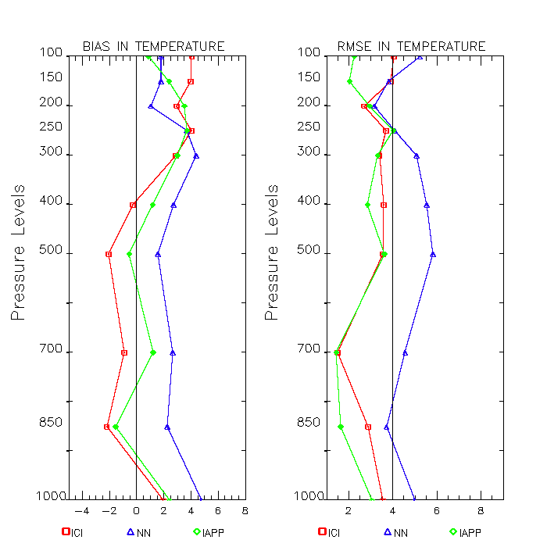
Fig-5(a) Fig-5(b)

3.2 Tropical Cyclone Analysis

The tropospheric temperature anomalies are computed for the study of tropical cyclones formed over Arabian Sea in the month of May and September , 2001. These tropical cyclones were of moderate intensity of T- number 3.0. The temperature profiles were retrieved using Neural Network Techniques on NOAA-16 AMSU-A data. The monthly mean temperature profiles were computed on 0.5x0.5 degree lat/lon grid by using all the temperature profiles of NOAA-16 for that particular month. The temperature anomalies were computed (temperature profile minus monthly mean temperature profile of that particular month.) at each level. The vertical cross section of temperature of May and September, 2001 cyclones are shown in fig. 1 (a, b) and fig. 2 (a, b) respectively. The cross section is at fixed latitude and at longitude from 64 deg. E –71 deg. E for May cyclone and 58 deg E – 68 deg E for September cyclone with a vertical extent of 100 hpa pressure level.

It may be seen from fig-1 (a) that the warm core of cyclone is centered at about 250 hpa with central location of 17.0 deg. N and 67.4 deg. E. The fig-1 (b) shows that on 28th of May , 2001 the tropical cyclone is weakened and moved to 20 deg. N and 69.4 deg. E with no sign of warm core temperature anomaly. This may be also observed from fig-3(a and b) which show the INSAT IR images of 26th and 28th may,2001. Similar behavior of tropical cyclone formed in the month of September has been observed. In fig- 2 (a) the warm core anomaly is located at the central position of tropical cyclone 18.5 deg. N and 66.0 deg. E about 250 hpa. Next day the cyclone has moved to 18.5 deg N and 62.5 deg. E with no sign of warm core temperature anomaly. This may be also observed from fig-4(a and b) which show the INSAT IR images of 26th and 27th september,2001.Tropical cyclone typically have a deep tropospheric layer of warm anomalies relative to their surroundings, with warmest anomalies near 300-250 hpa and maximum wind speed near the surface (Hawkins and Rubsam,1968; Hawkins and Imbembo, 1976; Frank, 1977 ). Microwave instruments can measure this upper level warm core quite well. In the past several methods have been developed using other microwave satellite data to utilize this measurement to make estimates of tropical cyclones intensity and surface pressure fields. (Kidder et al. 1978, 1980; Veldon and Smith et al 1991). The improved resolution of the AMSU observations has caused a resurgence of interest in these type of measurements. (Kidder et al 2000). It may be stated that the upper level warm temperature anomalies have very significant impact in order to assess the intensity of tropical cyclone.

4. Conclusion

The validation of temperature profiles with Radio-Sonde data show that the bias and rmse of temperature profiles derived using ICI and IAPP software packages are lower compared to Neural Network approach. Thus , it may be stated that ICI and IAPP packages have yielded better quality profile data without using any guess data. The temperature accuracy can be further improved by using surface and profile guess data of NWP model over Indian region. Further, it is observed that Microwave instruments can measure the upper level warm core quite well. Tropical cyclones typically have a deep tropospheric layer of warm anomalies relative to their surroundings, with warmest anomalies near 300-250 hpa. It is observed that the upper level warm temperature anomalies have very significant impact in order to assess the intensity of tropical cyclone.

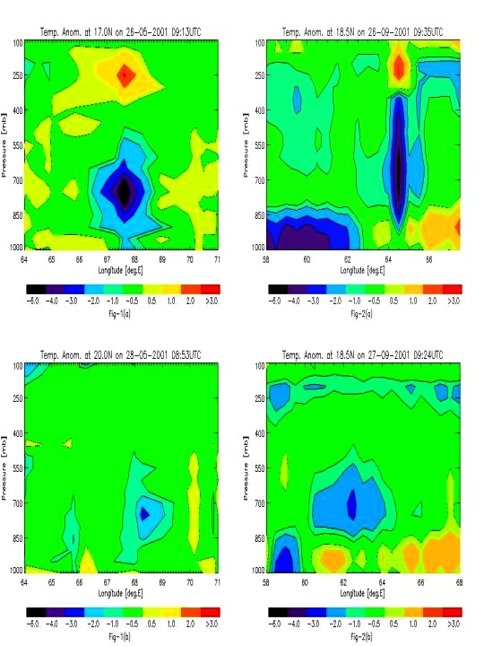

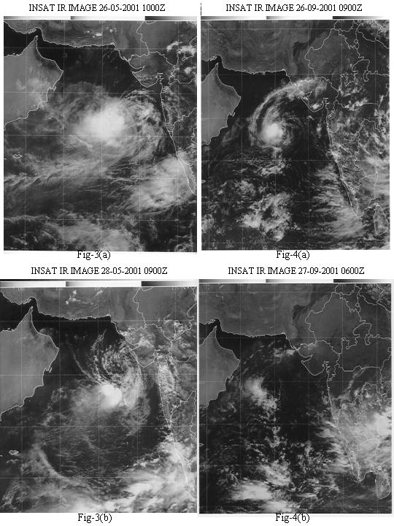

5. Ackowledgement

Authers are grateful to DGM, Dr. R.R.Kelkar for his constant encouragement during the course of study. Authers are very much thankful to Dr. Lavanant Lydie , Meteo-France for his tremendous help for the installations of the AAPP3.0 and ICI3.0 software packages.Thanks are also due to Dr. Paul Menzel, SSEC, University of Wisconsin for providing the IAPP2.0 Package and also due to Dr.Hal Woolf for providing the valuable software support .

6. REFERENCES

- Frank, W.M., 1977: the structure and energetics of the tropical cyclone1 : Storm structure, Mon..Wea.Rev., 105,1119-1135.
- Hawkins, H.F , and S.M. Imberbo, 1976:the structure of a small, intense hurricane- Inez 1966. Mon..Wea.Rev.,104,110,1956-1967.
- Hawkins, H.F , and D.T. Rubsam,1968: Hurricane Hilda, 1964 II. Structure and budgets of hurricane on Octobetr1 ,1964. Mon..Wea.Rev., 96,617-636.
- Khanna P. N., Kelker R. R. 1993 ‘ Temperature Sounding of the atmosphere over
Indian region using satellite data ‘ Mausam 1993, 44, 2 167- 174 pp.
- Klaes D., 1997 : ATOVS data processing in Europe, Technical proceedings of the ninth international TOVS Study Conference.
- Kidder, S.Q., W.M.Garg and T.H. Vonder Harr,1978: Estimating tropical
cyclone pressure and outer winds from satellite microwave data.
Mon..Wea.Rev., 106,1458- 1464.
7. Kidder, S.Q., W.M.Garg and T.H. Vonder Harr,1980: Tropical cyclone outer
surface winds derived from satellite microwave data.
Mon..Wea.Rev.,108,144-1527.
- Kidder,S.Q., M.D. Goldbrig,R.M. Zehr, M.DeMaria, J.F.W. Purdom,C.S.Veldon, N.C.Grodg and S.J. Kusselson, 2000: Satellite analysis of tropical cyclones using Advanced Microwave Sounding Unit (AMSU). Bull. Amer. Meteor.Soc., 1,1241- 1259 .
- Lavanant L., Brunel P., Rochard G., Labrot T., 1999: Noaa15 sounding profiles retrieved with the ICI scheme. ITSC no10.
- Lavanant L., Brunel P., 1999 : Description document for the ICI sounding software related to meteorological NOAA orbiting satellites. Vol 1 : scientific section. Vol 2 : software architecture. Météo-France report.
11. Smith W.L; et al 1979, ‘ The TIROS - N Operational Vertical
Sounder ‘ BAMS, 60, 10, 1177 - 1187 pp.

