NPP Instruments and Direct Broadcast Plans

W. Paul Menzel
Office of Research and Applications , NOAA / NESDIS,
Madison,WI, USA

Abstract

The National Polar-orbiting Operational Environmental Satellite System (NPOESS) is a joint NOAA/DOC, DoD and NASA program merging the current POES & DMSP systems into a common system of polar satellites with the goal of providing meteorological, oceanographic, terrestrial, climate, space environment and other environmental data products operationally. NPOESS will produce accurate and precise long-time series of radiometric measurement data from multiple instruments on multiple platforms starting late this decade. To prepare for the new instruments and data, the USA is planning an NPOESS Preparatory Project (NPP) that will demonstrate three of the NPOESS instruments as well as the associated ground data system, command and control system, and algorithms for Environmental Data Records in 2005. It is a bridge between NASA EOS era science measurements and the start of NPOESS operational capabilities. NPP provides a linkage between EOS instrumentation and the NPOESS series of instruments. The NPP will carry the Visible Infrared Imaging Radiometer Suite (VIIRS), the Cross track Infrared Sounder (CrIS), and the Advanced Technology Microwave Sounder (ATMS). NPP will feature an X-band direct broadcast of all data to facilitate international utilization.

1. VIIRS

The Moderate resolution Imaging Spectro-radiometer (MODIS) on the AM platform of the NASA Earth Observing System, Terra, has been demonstrating new capabilities for detecting land, ocean, and atmospheric features. With 36 multispectral observations at resolutions ranging from 250 m to 1000m, MODIS is generating environmental research data and products of exceptional quality. Several examples developed by the MODIS Science Team are presented. The NPOESS will continue these observations with the Visible Infrared Imaging Radiometer Suite (VIIRS), a 22 channel radiometer with resolutions ranging from 400 to 800m. VIIRS represents a significant advance in operational polar orbiting imagers. Differences in the MODIS and VIIRS instruments spectral bands and their product capabilities are discussed.

1a. Characteristics of the MODIS and VIIRS Measurements

The MODIS is a scanning spectro-radiometer with 36 spectral bands between 0.645 and 14.235 μm (King et al. 1992). Table 1 lists the MODIS spectral channels and their primary application. Bands 1 - 2 are sensed with a spatial resolution of 250 m, bands 3 - 7 at 500 m, and the remaining bands 8 – 36 at 1000 m. The signal to noise ratio in the reflective bands ranges from 50 to 1000; the noise equivalent temperature difference in the emissive bands ranges from 0.1 to 0.5 K (larger at longer wavelengths).

Table 1: MODIS Channel Number, Wavelength (μm), and Primary Application

Reflective Bands Emissive Bands
1,2 0.645, 0.865 land/cld boundaries 20-23 3.750(2), 3.959, 4.050 sfc/cld temperature
3,4 0.470, 0.555 land/cld properties 24,25 4.465, 4.515 atm temperature
5-7 1.24, 1.64, 2.13 “ 27,28 6.715, 7.325 water vapor
8-10 0.415, 0.443, 0.490 ocean color/chlorophyll 29 8.55 sfc/cld temperature
11-13 0.531, 0.565, 0.653 “ 30 9.73 ozone
14-16 0.681, 0.75, 0.865 “ 31,32 11.03, 12.02 sfc/cld temperature
17-19 0.905, 0.936, 0.940 atm water vapor 33-36 13.335, 13.635, 13.935, 14.235 cld top properties
26 1.375 cirrus clouds

The VIIRS spectro-radiometer features a modular design with 22 spectral bands between 0.4 and 12 μm, mature visible and infrared calibration systems, and MODIS heritage. Table 2 lists the VIIRS spectral channels and their primary application. Bands I are sensed with a spatial resolution of 400 m and bands M at 800 m. The signal to noise ratio in the reflective bands ranges from 25 to 1000; the noise equivalent temperature difference in the emissive bands ranges from 0.03 to 0.4 K (larger values for the I bands).

Table 2: VIIRS Channel Number, Wavelength (μm), and Primary EDR Application

Reflective Bands
M1,2 0.412, 0.450 ocean color / aerosol
M3,4 0.488, 0.555 ocean color / aerosol
I1 0.630 imagery
M5 0.672 ocean color / aerosol
M6,7 0.751, 0.865 atm corr
I2 0.865 NDVI
M8 1.24 cld particle size
M9 1.378 cirrus
M10 1.61 snow fraction
I3 1.61 snow map
M11 2.26 clouds
Emissive Bands
M12 3.7 SST
I4 3.74 imagery / clouds
M13 4.05 SST / fires
M14 8.55 cld top properties
M15 10.8 SST
I5 11.55 cloud imagery
M16 12.0 SST

A noteworthy difference in the two instruments is the lack of any VIIRS infrared channels in the CO2, H2O, and O3 absorption bands. This restricts night-time cloud and moisture detection. Figure 1 shows the spectral bands superimposed on the earth reflection and emission spectra.

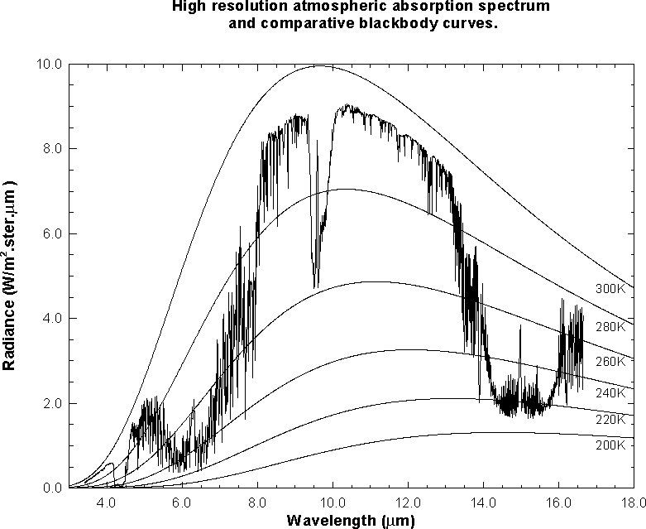
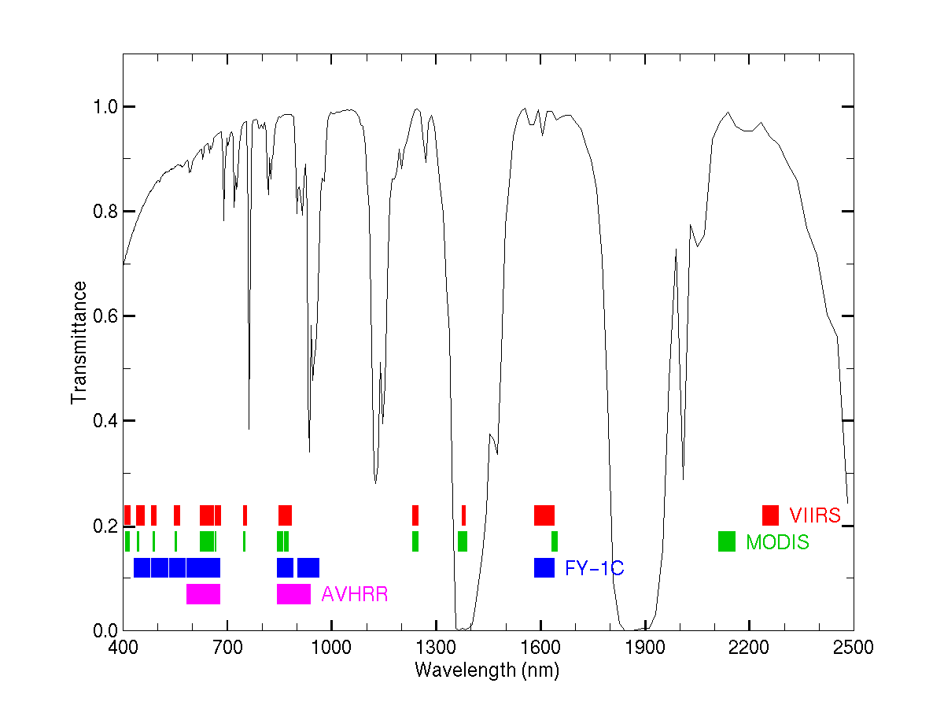
MODIS
VIIRS

Figure 1: VIIRS and MODIS reflective (top) and emissive (bottom) spectral bands shown superimposed on the earth reflection and emission spectra.

1b. MODIS standard data products and VIIRS EDRs

MODIS standard data products include (a) cloud detection, (b) aerosol concentration and optical properties during the day, (c) cloud optical thickness, effective particle size, thermodynamic phase, top pressure, and top temperature, (d) atmospheric moisture gradients, (e) vegetation and land surface cover, (f) snow and sea-ice cover, (g) surface temperature, (h) ocean leaving spectral radiances and color, and (i) chlorolphyll concentration and fluorescence.

VIIRS is responsible for many Environmental Data Records (EDRs). Top category is allocated to Imagery and Sea Surface Temperature. Other EDRs where VIIRS is the primary contributor include Aerosol Optical Thickness, Aerosol Particle Size, Albedo (Surface), Cloud Cover/Layers, Cloud Effective Particle Size, Cloud Optical Thickness, Cloud Top Height/Pressure/Temperature, Ocean Color, Vegetation Index, Suspended Matter, Surface Type, Land and Ice Surface Temperature, Sea Ice Characterization, Snow Cover/Depth , Net Heat Flux, and Cloud Base Height.

1c. Analyses of Cloud Presence

By using many bands in the visible, near-infrared, and infrared portions of the spectrum at 1-km resolution, improved discrimination between clear and cloudy sky conditions is possible (Ackerman et al., 1998). The reflective bands are used for several cloud tests: (a) reflectance 3.9 μm threshold test; (b) reflectance 1.38 μm threshold indicates presence of thin cirrus cloud; (c) reflectance vegetation ratio test with 0.87 over 0.66 μm; and (d) snow test using 0.55 and 1.6 μm. The emissive bands are used as follows: (a) IR window brightness temperature threshold and difference tests using 8.6, 11, and 12 μm radiances which are sensitive to surface emissivity, atmospheric moisture, dust, and aerosols; and (b) CO2 channel 13.9 micron test for high clouds (available on MODIS only). Figure 2 shows the global composite of the average clear-sky MODIS band 31 (11 μm) brightness temperature after filtering out cloud scenes with the cloud mask. The image represents the average values at 25-km resolution for 5-8 September 2000. Composite images like these have been used extensively in the quality assurance and algorithm adjustment of the cloud mask.

Multispectral investigation of a scene can separate cloud and clear scenes into various classes. Cloud and snow appear very similar in a 0.645 μm image, but dissimilar in a 1.6 μm image (snow reflects less at 1.6 than 0.645 μm). For 8.6 μm ice/water particle absorption is minimal, while atmospheric water vapor absorption is moderate. For 11 μm, the opposite is true. Using these two bands in tandem, cloud properties can be distinguished. Large positive brightness temperature (BT) differences in 8 minus 11 microns indicate the presence of cirrus clouds; negative differences indicate low water clouds or clear skies. Cloud boundaries are often evident in local standard deviation of radiances. Figure3 presents the scatter plots of several bands, LSD, and BT differences versus 11 μm BT for MODIS data collected over the eastern United States on 17 December 2000. Snow and cloud are separated by 1.6 μm, while low and higher clouds are distinguished by 8.6-11 μm BT.

Figure 2. Composite clear-sky 11 μm brightness temperature for 5-8 September 2000 MODIS (red-315 K yellow-295 K, blue-265 K)

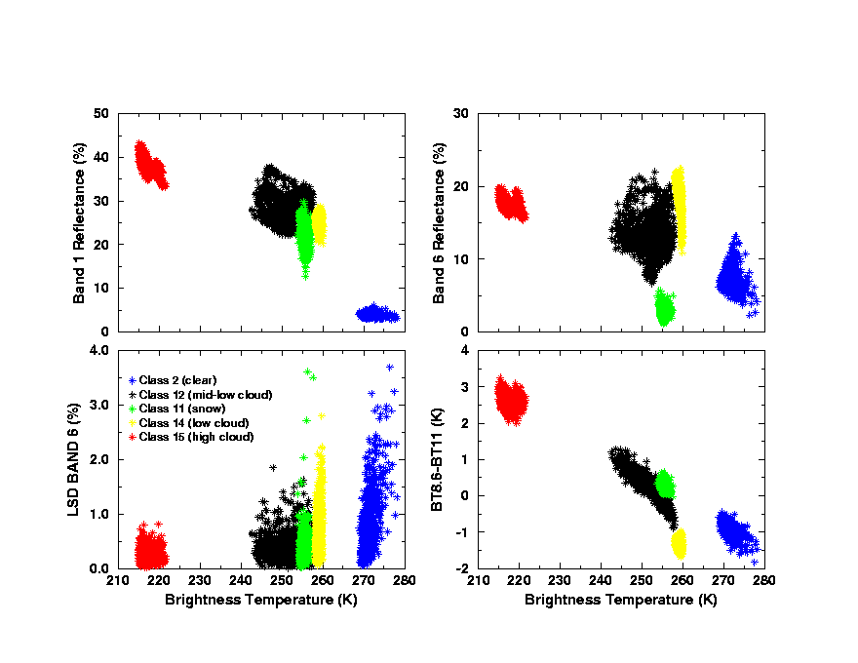
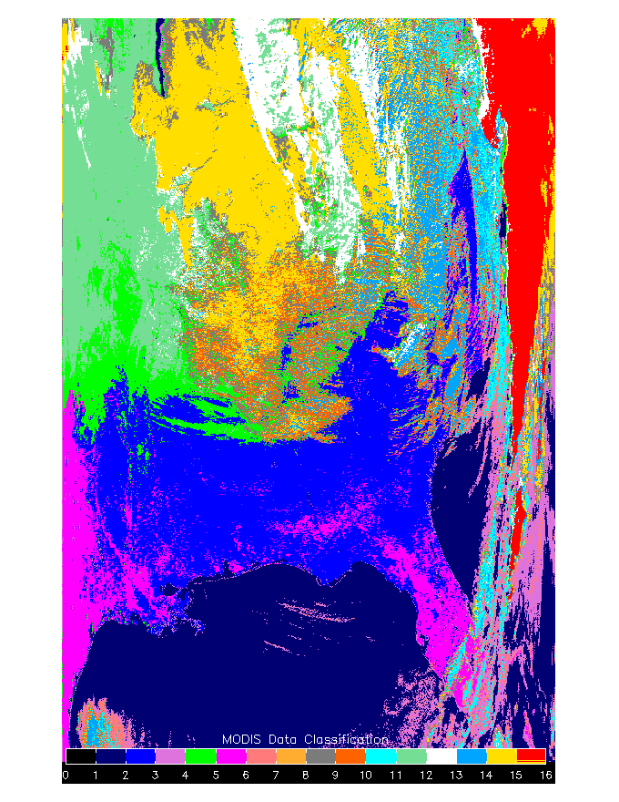

Figure 3: (left) Scatter plots of MODIS 0.645 μm band 1 (upper left panel), 1.6 μm band 6 (upper right panel), Local Standard Deviation (LSD) of band 6 (lower left panel), 8.6 minus 11 μm (lower right panel ) and versus 11 μm brightness temperature for clear (blue) snow (green), low clouds (yellow), mid-low clouds (black), high clouds (red). (right) Cloud classification for eastern United States on 17 December 2000 at 1640 UTC.

1d. Enhancing VIIRS

Strong scientific justification for a water vapor sensitive spectral band (improving cloud identification of polar clouds at night, estimating heights for semi-transparent clouds, tracking atmospheric motions in polar regions day and night in sequences of images, monitoring global upper tropospheric humidity features for the global water vapor experiment) has prompted investigation of enhancing VIIRS with a channel in the 6.5 μm spectral region. This will be especially important for cloud identification in the polar winter where temperature inversions confuse traditional window channel approaches. In semi-transparent clouds the water vapor channel can help to correct for radiation emanating from below the cloud and thus better assign the cloud height.

2. CrIS

The Cross-track Infrared Sounder (CrIS) consists of a Michelson interferometer infrared sounder covering the spectral range of approximately 3.5 to 15.4 microns. The CrIS provides cross-track measurements of scene radiance to permit the calculation of the vertical distribution of temperature and moisture in the Earth's atmosphere. It also provides supporting measurements for a variety of other geophysical parameters as listed in the NPOESS Integrated Operational Requirements Document [IORD]. CrIS data will be analyzed together with that of the co-registered microwave cross-track sounder, ATMS.
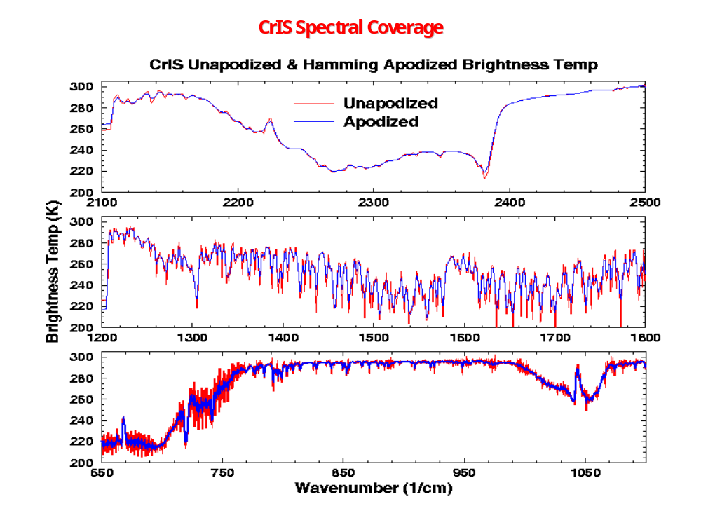
Figure 4: CrIS spectral coverage in the shortwave (top) midwave (middle) and longwave (bottom) IR.

Table 3: CrIS sensor performance parameters

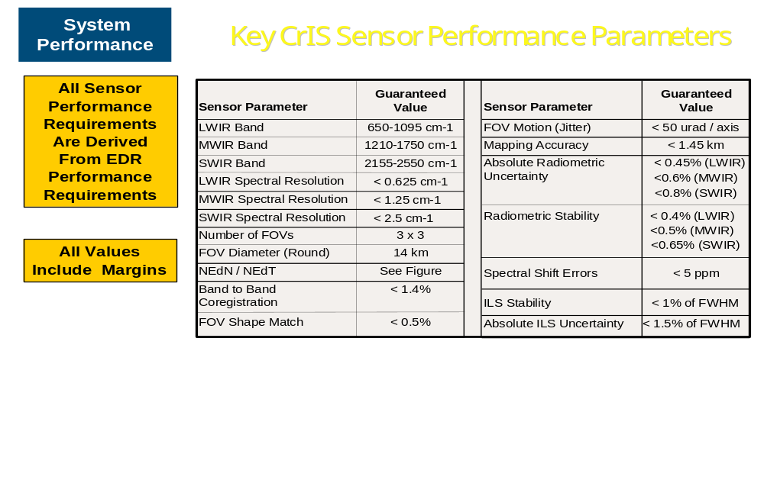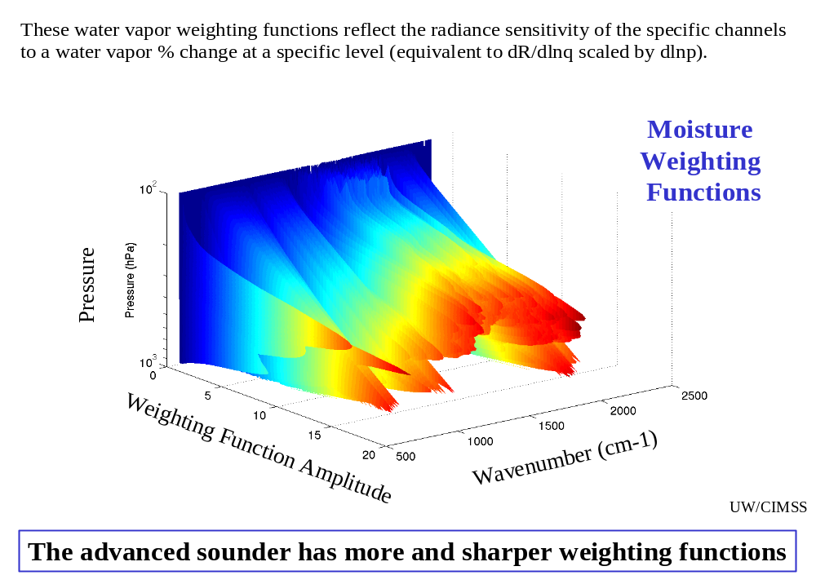

Figure 5: Moisture weighting functions from a CrIS-like interferometer.

3. ATMS

The Advanced Technology Microwave Sounder (ATMS) has a current notional baseline performance level that is better or equal to that currently projected for the Advanced Microwave Sounder Unit-A (AMSU-A) and the Advanced Microwave Sounder Unit-B/Microwave Humidity Sounder (AMSU-B/MHS) microwave sounders. ATMS was designed with 22 spectral channels, including 23, 31, several 50, 89, 166, and several 183 GHz channels. ATMS is the follow on the Advanced Microwave Sounding Unit (AMSU) and has improvements in several respects. ATMS will have no gaps in its earth coverage; this enhances hurricane, water vapor, and precipitation monitoring. ATMS will have 33 km resolution near 50 GHz (better than the AMSU 50 km). ATMS will have a signal-to-noise ratio as good as AMSU when degraded to the AMSU spatial resolution. ATMS oversampling near 54 GHz will exceed Nyquist across track and equal Nyquist along track. ATMS spectrally close band pairs will generally have about the same spatial beam width to facilitate multispectral applications.

Table 4: AMSU Spectral Bands

Ch n(GHz) BW(GHz) Characteristic

1* 23.8 0.27 split window-water vapor 100 mm
2* 31.4 0.18 split window-water vapor 500 mm
3* 50.3 0.18 window-surface emissivity
4 51.76 0.40 window-surface emissivity
5* 52.8 0.40 surface air
6* 53.596±.115 0.17 4 km ~ 700 mb temp and precip
7* 54.4 0.40 9 km ~ 400 mb temp and precip
8* 54.94 0.40 11 km ~ 250 mb
9* 55.5 0.33 13 km ~ 180 mb
10* 57.2903 0.33 17 km ~ 90 mb
11* 57.2903 ±.217 0.078 19 km ~ 50 mb
12* 57.2903 ±.322 ±.048 0.036 25 km ~ 25 mb
13* 57.2903 ±.322 ±.022 0.016 29 km ~ 10 mb
14* 57.2903 ±.322 ±.010 0.008 32 km ~ 6 mb
15* 57.2903 ±.322 ±.004 0.03 37 km ~ 3 mb
16* 89.0 6.0 window-precip and water vapor 150 mm
17 166.31 4.0 H2O 18 mm
18* 183.31±7 2.0 H2O 8 mm
19 183.31±4.5 2.0 H2O 4.5 mm
20* 183.31±3 1.0 H2O 2.5 mm
21 183.31±1.8 1.0 H2O 1.2 mm
22* 183.31±1 0.5 H2O 0.5 mm

* In common with AMSU/HSB

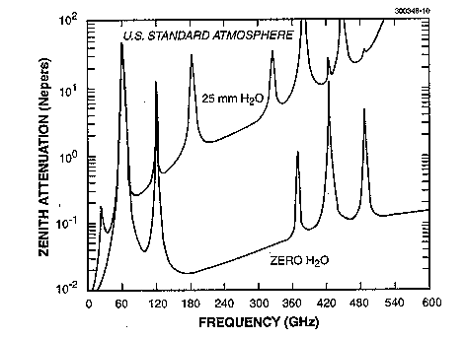
Figure 6: Microwave spectra with and without H2O in the atmosphere

4. Direct Broadcast and Access to Products

NPP global Stored Mission Data (SMD) will be routed to four U.S. Operational Processing Centres for processing into Raw Data Records (RDR), Sensor Data Records (SDR), and Environmental Data Records (EDR). The RDR will be full resolution, unprocessed digital sensor data, time-referenced and earth located (or orbit-located for in-situ measurements), with radiometric and geometric calibration coefficients appended to the data. SDRs will be full resolution sensor data that are time referenced, earth located and calibrated by applying the ancillary information, including radiometric and geometric calibration coefficients and geo-referencing parameters. EDRs are fully processed sensor data containing the environmental parameters or imagery that must be generated as user products. NESDIS will provide the world-wide user community access to near real-time processed NPP data and higher-level products via the NESDIS Central Environmental Satellite Computer System (CEMSCS) servers, as well as access to archived NPP data via other distributed servers at the NESDIS Data Centres. HRD X-band data (at 20mbs) will be available from NPP.

The NPOESS web site (npoesslib.ipo.noaa.gov/electlib.htm) continues to be a useful site for finding summaries of the NPP instruments as well as new information.

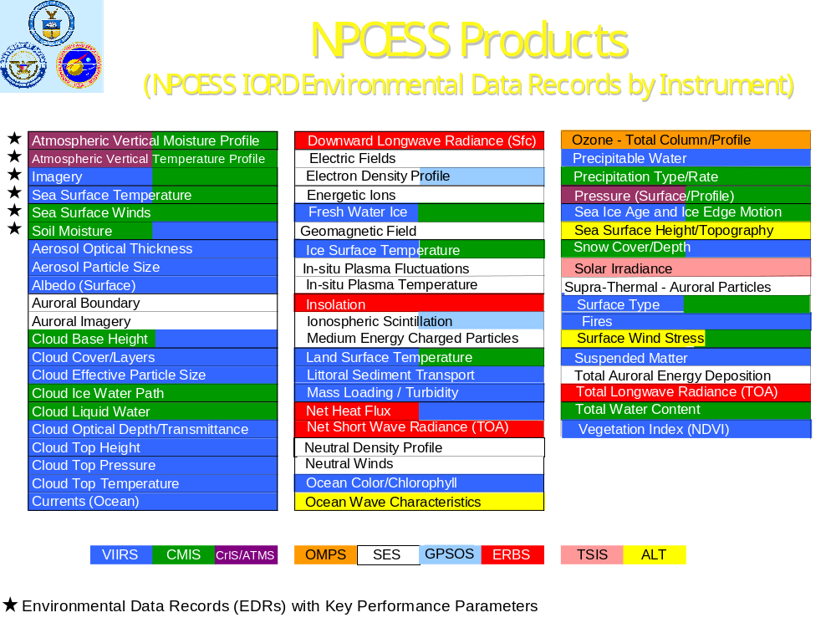Figure 7: Environmental Data Records expected from the NPOESS (NPP will deliver only the VIIRS, CrIS, ATMS subset)

