Radiocommunication Study Groups | 
Source: Document 7C/TEMP/10 | Annex 4 to  Document 7C/32-E
Source: Document 7C/TEMP/10 | 11 April 2008
Source: Document 7C/TEMP/10 | English only
Annex 4 to Working Party 7C Chairman’s Report
working document towards a report or recommendation on the use of passive remote sensing spectrum
between 275 and 3 000 GHz

1 Introduction
The agenda for the 2011 World Radiocommunication Conference, as given in Resolution 805 (WRC-07), contains Agenda item 1.6 as follows:
1.6 to review No. 5.565 of the Radio Regulations in order to update the spectrum use by the passive services between 275 GHz and 3 000 GHz, in accordance with Resolution 950 (Rev.WRC-07), and to consider possible procedures for free-space optical-links, taking into account the results of ITU-R studies, in accordance with Resolution 955 (WRC-07);
It should be noted that AI 1.6 will not consider frequency allocations which are specifically excluded from this agenda item.
Resolution 950 (Rev.WRC-07) invites the ITU-R:
to conduct the necessary studies in time for consideration by WRC-11 with a view to the modification of No. 5.565, including advice on the applications suitable for the band 275-3 000 GHz;
This document is comprised of the initial information submitted to WP 7C on the use of passive remote sensing spectrum in this frequency range. This working document could evolve into an ITU-R Report or Recommendation or the information could be used to update existing Recommendation(s) as appropriate when the information becomes more mature. Additionally, when this information becomes mature, it should be used to revise Recommendation ITU-R RS.515-4 as appropriate.

2 International coordination of passive remote sensing bands definition
In order to ensure an effective resolution of this agenda item at WRC-11, international coordination among all the potential users of these bands should be applied. This would ensure that consistent proposals be submitted by the various regional groups to WRC-11, and will therefore minimize the need for technical discussions at that stage.
Examples of potential international bodies with which consultations could occur are:
– The Space Frequency Coordination Group (SFCG) (http://www.sfcgonline.org). The SFCG has existed for 28 years. It federates all the main civilian space agencies of the world. Frequency managers from these agencies attend the yearly meetings of this group, normally held in September. In the past years specific workshops organized by NOAA, the United States meteorological agency, concerning satellite remote sensing were triggered by the SFCG and the output of these workshops could represent a starting element for this activity. Some of the information presented in this document is based on information from these workshops.
– The IEEE GRSS/FARS (IEEE Geoscience and Remote Sensing Society/ Frequency Allocations in Remote Sensing – http://www.grss-ieee.org). It deals with the purely technical aspects of remote sensing. The IEEE GRSS sponsors an annual symposium/conference (next meeting July 2008 in Boston, MA, USA).
– ITWG (The International TOVS Working Group – http://cimss.ssec.wisc.edu/itwg/). It deals with the operational and research users of TIROS Operational Vertical Sounder (TOVS) data from the NOAA series of polar orbiting satellites and other atmospheric sounding data. The group exchanges information on methods for extracting information from these data on atmospheric temperature and moisture fields and on the impact of these data in numerical weather prediction and in climate studies.

3 Guidelines for the identification of the revised No. 5.565 frequency bands
In order to have a consistent identification of the revised No. 5.565 frequency bands and to ensure the technical credibility of any such proposal, the following general guidelines should be followed:
1) for each frequency band the specific spectral line(s) and reference windows should be identified (atmospheric component and spectral line frequency or central frequency for reference windows);
2) the required bandwidth should be minimized and technically consistent with the required resolution of the measurement;
3) in case of atmospheric components that can be measured at different frequencies, technical/scientific reasons justifying each of the options should be given.

4 Current information
The bands noted in RR 5.565 in the current version of the Radio Regulations are as follows:
“– Earth exploration-satellite service (passive) and space research service (passive): 275-277 GHz,
294-306 GHz, 316-334 GHz, 342-349 GHz, 363-365 GHz, 371-389 GHz, 416-434 GHz, 442-444 GHz, 496-506 GHz, 546-568 GHz, 624-629 GHz, 634-654 GHz, 659-661 GHz, 684-692 GHz, 730-732 GHz, 851-853 GHz and 951-956 GHz.”
These same bands are also reflected in Recommendation ITU-R RS.515-4 and are excerpted from that Recommendation as given in Table 1. It should be noted that the footnote was last modified at WRC-2000 and the contents of the Recommendation have not been updated since 2003. While it may be necessary to identify new bands not previously considered, it also may be necessary to remove bands based on experience and information developed in the intervening time period.
table 1
Passive sensing bands between 275 and 1 000 GHz as given in
Recommendation ITU-R RS.515-4
Frequency band(s)  (GHz) | Total bandwidth required (MHz) | Spectral line(s) or centre frequency  (GHz) | Measurement | Scan  mode  N, L
275-277 | 2 000 | 276.33 | NO, N₂O (276.33 GHz) | L
294-306 | 12 000 | 301.44 | NO, N₂O (301.44 GHz), O₃, O₂, HNO₃, HOCl | N, L
316-334 | 18 000 | 325.15 | Water vapour profiling (325.1 GHz), O₃, HOCl | N, L
342-349 | 7 000 | 345.8, 346 | CO (345.8 GHz), HNO₃, CH₃Cl, O₃, oxygen, HOCl | N, L
363-365 | 2 000 | 364.32 | O₃ | L
371-389 | 18 000 | 380.2 | Water vapour profiling | N
416-434 | 18 000 | 425 | Temperature profiling | N
442-444 | 2 000 | 443 | H₂O, O₃, HNO₃, N₂O, CO | N, L
496-506 | 10 000 | 498.1, 498.2, 498.3, 498.4, 498.5, 498.6 | O₃, CH₃Cl, N₂O, BrO, ClO, water vapour profiling | N, L
546-568 | 22 000 | 557 | Water vapour profiling | N, L
624-629 | 5 000 | 624.27, 624.34, 624.77, 625.37, 625.92, 627.18, 627.77, 628.46 | HCl, BrO, O3, HCl, SO2, H2O2 | L
634-654 | 20 000 | 635.87, 642.85, 647.2, 649.45, 649.7, 650.28, 650.73, 651.77, 652.83 | CH3Cl, HOCl, ClO, water vapour, N2O, BrO, O3 | N, L
659-661 | 2 000 | 660.49 | BrO | L
684-692 | 8 000 | 688 | ClO, CO, CH3Cl | L
730-732 | 2 000 | 731 | Oxygen, HNO3 | L
851-853 | 2 000 | 852 | NO | L
951-956 | 5 000 | 952, 955 | Oxygen, NO | L

5 Current/planned systems
In order to determine whether or not bands between 275 and 1 000 GHz will need to be added to the existing footnote and Recommendation, current and planned passive remote sensing systems were examined. Additionally, some of these systems either use or plan to use frequency bands in the 1 000 to 3 000 GHz range and these bands are not contained in either the existing footnote or the current version of the Recommendation. Possible candidate bands between 275 GHz and 3 000 GHz are given in Table 2.
table 2
Passive sensing bands, their associated systems and measurements in 275-3 000 GHz
Frequency band(s) (GHz) | Spectral line(s) (GHz) | Instrument(s) | Measurement | Scan  Mode
275-277 | 276.33 | [TBD] | NO, N₂O (276.33 GHz) | Limb
296-306 | Window for 325.1 | [TBD] | 296-306 GHz to be used as window for water vapour line at 325.1 GHz | Nadir
298-306 | 298.5,  300, 301.44,  304, 305.2 | MLS, MASTER | NO, N₂O (301.44 GHz), O₃, O₂, HNO₃, HOCl | Limb
316-334 | 325.15 | [TBD] | ± 9.0 GHz around water vapour line at 325.1 GHz to be used for nadir sensing from GEO plus wings | Nadir
321-326 | 321, 322.8,  325.15 | MASTER | Water vapour profiling (325.1 GHz), O₃, HOCl | Limb
339-348 | Window for 380.2 | [TBD] | 339-348 GHz to be used for window for water vapour sounding, precipitation cell imaging, and cloud ice water path measurement | Nadir
342-346 | 343.8, 344.4,  345.0, 345.5,  345.8, 346 | GEM, MASTER | CO (345.8 GHz), HNO₃, CH₃Cl, O₃, oxygen, ClO, HOCl | Limb
363-365 | 364.32 | [TBD] | O₃ line (364.32 GHz) | Limb
371-389 | 380.2 | [TBD] | 371-389 to be used for water vapour profiling for close to nadir sounding from GEO | Nadir
379-381 | 380.2 | GEM, GOMAS | Water vapour sounding (limb & nadir) | Limb,  Nadir
409-411 | 410 | GEM | Temperature sounding | Limb
416-433 | 424.7 | GEM, GOMAS | Temperature profiling around 424.7 oxygen line | Nadir, Limb
442-444 | 442.99 | [TBD] | H₂O, O₃, HNO₃, N₂O, CO | Nadir, Limb
459-466 | 462.6 | CLOUDS | Ice clouds | Conical
486-489 | 487.25 | ODIN | Oxygen line at 487.25 | Limb
498-502 | Window for 556.9 | [TBD] | Water vapour sounding, near nadir GEO | Nadir
497-499 | 498.1, 498.2,  498.3, 498.4,  498.5, 498.6 | SOPRANO, MASTER, ODIN | O₃, CH₃Cl, N₂O, BrO, ClO | Limb
523-527 | Window for 556.9 | [TBD] | Water vapour sounding (near nadir GEO) | Nadir
538-542 | Window for 556.9 | [TBD] | Water vapour sounding (near nadir GEO) | Nadir
541-558 | [541.26, 542.35, 544.99, 550.90, 556.98] | [TBD] | HNO₃, and O₃ lines | Limb
552-562 | 556.93 | ODIN | Water vapour sounding (near nadir GEO) | Nadir
546-568 | 556.93 | ODIN | Water vapour profiling (limb) and mesospheric water | Nadir
563-581 | [566.29, 571.0, 575.4] | ODIN | ClO and O₃ lines | Limb
624-629 | 624.27, 624.34,  624.77, 625.37, 625.66, 625.92, 627.18, 627.77, 628.46 | MLS, SMILES, SOPRANO | ClO₂ (624.271 GHz), SO₂ (624.344 GHz), BrO (624.77 GHz), O₃ (625.656 GHz), HCl (625.92 GHz), CH₃Cl (627.177 GHz), O₂ (627.773 GHz), HOCl (628.46 GHz) | Limb
634-653 | 635.87, 647.2, 649.45, 649.7, 650.18, 650.28, 650.73, 651.77, 652.83 | MLS, SMILES | HOCl (635.87 GHz), H₂O (647.198 GHz), ClO (649.451 GHz), HO₂ (649.701 GHz), BrO (650.179 GHz), HNO₃ (650.279 GHz), O₃ (650.733 GHz), NO (651.771 GHz), N₂O (652.834 GHz) | Limb
659-661 | 660.49 | MLS | HO₂ line | Limb
677-692 | 688 | CLOUDS | ClO, CO, CH₃Cl line around 688 GHz; ice clouds | Limb, Conical
730-732 | 731 | [TBD] | Oxygen, HNO₃ | Limb
851-853 | 852 | [TBD] | NO | Limb
868-881 | 874.5 | CLOUDS | Ice clouds | Conical
951-956 | 952, 955 | SOPRANO | O₂ (952 GHz), NO (953 GHz) | Limb
1 228-1 230 | 1 228.95 | [MLS?] | HF | Limb
2 500-2 540 | 2 502.32, 2 509.95,  2 514.32, 2 522.78 | MLS | Oxygen, OH | Limb

6 Spectral lines and windows between 275 and 1 000 GHz
A great deal of work has been done regarding the relative sensitivity of the radio spectrum to various atmospheric constituents as well as atmospheric temperature and water vapour variations. It appears that the frequency range between 275 and 600 GHz is of interest for both nadir sounding and microwave limb sounding. However, the range from about 600 GHz to 3 000 GHz seems to be more of interest for microwave limb sounding and the many spectral lines for various atmospheric constituents. Figure 1 shows the sensitivity of millimeter and sub-millimeter frequencies to atmospheric temperature and water vapour variations between 2 and 1 000 GHz. The water vapour and oxygen resonance spectral lines are indicated in the Figure as well. In comparing these resonance spectral lines with the information in Table 2, it is noted that water vapour and oxygen spectral lines between 600 GHz and 1 000 GHz, enumerated in Table 3, have not been included in Table 2 except for a few cases. This information will need to be integrated with the information in Table 2 and then compared with Table 1 in order to determine where changes need to be made in Recommendation ITU-R RS.515-4.
table 3
Water vapour and oxygen resonance spectral
lines between 600 and 1 000 GHz
Resonant frequency (GHz) | Species
620.7008 | Water vapour
658.0065 | Water vapour
715.3931 | Oxygen
752.0332 | Water vapour
773.8397 | Oxygen
834.1453 | Oxygen
859.8650 | Water vapour
916.1716 | Water vapour
970.3150 | Water vapour
987.9268 | Water vapour

It will have to be determined whether or not these spectral lines are of importance to the study of the Earth’s atmosphere as well as climatology and need to be included in Table 2.
figure 1
Zenith opacity with oxygen and water vapour spectral lines below 1 000 GHz
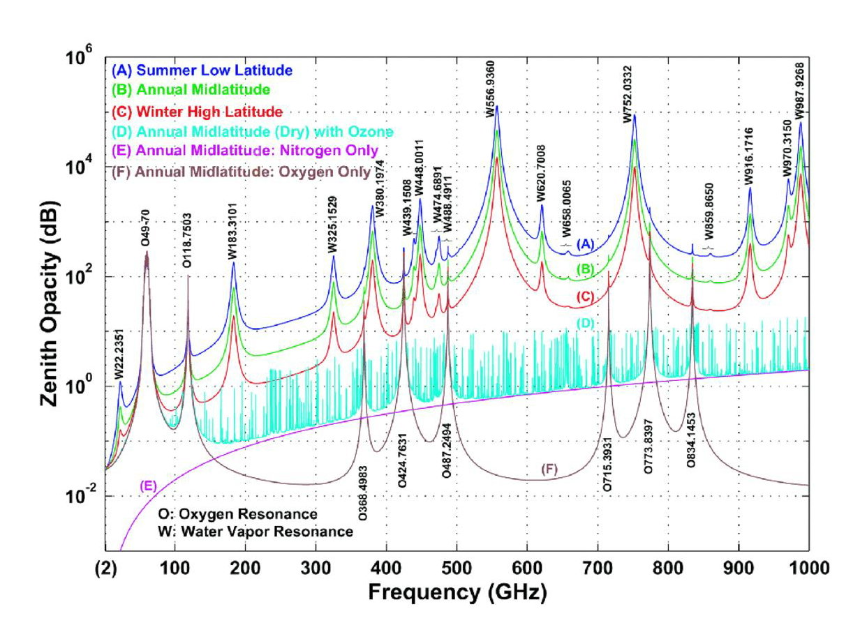
From: A.J. Gasiewski and M. Klein, “The sensitivity of millimeter and sub-millimeter frequencies to atmospheric temperature and water vapour variations”, Journal of Geophysical Research-Atmospheres, 13, pp. 17 481-17 511, 2000

Recommendation ITU-R P.836 provides worldwide maps of the atmospheric water vapour content at ground level. These maps are yearly averages, calculated on the basis of 10 years radiosonde data for 323 sites all over the world, covering more or less all climate regions. Table 1 compares the values of water vapour density and total columnar content at ground level, as given by the ATM model and the ITU-R Recommendation, and shows a fair correspondence.
The statistical indication given in the Recommendation concerning the total columnar content (exceeded for 10%, or not exceeded for 90%, of the average year) is interesting and shows that water vapour as an essential, but unreliable shielding parameter against interference generated from the Earth’s surface which must be considered with great care.
Table 4
Water vapour surface density and total columnar content
 | Rec. ITU-R P.836 |  |  | ATM model
Climate/season | Surface density (g/m³) | Total column (kg/m²) | Surface density (g/m³) |  | Total column (kg/m²)
Tropical | 20 to 25 | < 50 (90% of time) | 18 |  | 41
Mid-latitude summer | 10 to 15 | < 30.(90% of time) | 13.5 |  | 29.5
Mid-latitude winter | 5 to 10 | < 30 (90% of time) | 3.5 |  | 8.6
Sub-arctic summer | 5 to10 | < 22 (90% of time) | 8.7 |  | 21
Sub-arctic winter | 2 to 5 | < 22 (90% of time) | 1.3 |  | 4.2

The linear absorptions due to the dry components and due to the dry plus humid components are shown on Fig. 2. The water vapour is largely the dominant parameter. The magnitude of linear absorption at ground level will be used in the study to evaluate the density of potential interfering terrestrial services which may be within the sensor’s field of view. Above 275 GHz, the linear absorption is extremely high due to the vicinity of multiple powerful resonances, ranging from approximately 35 dB/km in the lowest part of the frequency band considered, up to more than 10⁴ dB/km in the strongest H₂O absorption lines.
Figure 2
Linear absorption at ground level from Recommendation ITU-R P.676
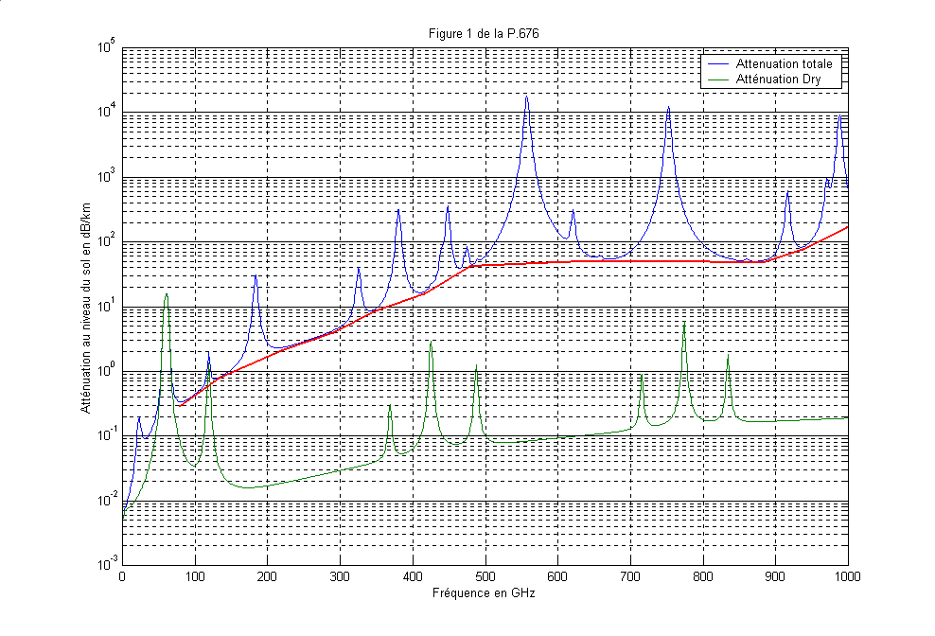
Figure 3
Vertical opacity due to H₂O + O₂ lines and wet + dry continuum
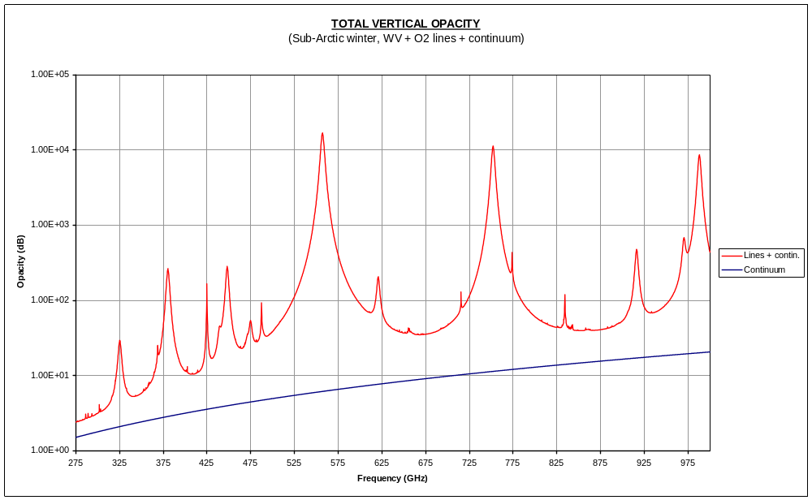

Figure 3 shows the vertical opacity due to water vapour lines, oxygen lines and continuum. The total continuum is indicated only for reference, showing that the absorption is essentially due to H₂O resonances. Note the steep increase of average opacity with frequency.

7 Example of remote sensing of cirrus and ice clouds
Water, including ice, is located in the clouds in the upper-troposphere (from 6-14 km in altitude) and is one more piece in the hydrologic puzzle. Unlike liquid water, ice is essentially non-absorbing in the microwave. Thermal sub-millimeter radiation emitted from below the cirrus cloud layer is scattered (rather than absorbed) by the ice crystals. This reduces the brightness temperature as seen from above the cloud. Since water vapour is fairly opaque to sub-millimeter wavelengths, most of the radiation originates in the middle troposphere. As a result the surface is obscured and unimportant. Infrared (IR) measures only a very thin upper cloud layer, while millimeter and sub-millimeter wave radiometry measures the lower levels. Experimental instrumentation has been built and flown on aircraft, and a few sub-millimeter wavelength radiometers have been flown on satellites. Recent studies have examined the potential benefits of instruments using various frequency channels and have derived a theoretical best set of channels for future exploitation (see Table 5). Many of these optimal channels are located in frequency bands that are not currently listed in RR 5.565.

8 Spectral lines between 1 000 and 3 000 GHz
There are a large number of spectral lines that may be of interest for atmospheric limb sounding between 1 000 GHz and 3 000 GHz. A good source for information on these spectral lines is the Jet Propulsion Laboratory (JPL) Molecular Spectroscopy Catalogue which can be accessed at: http://spec.jpl.nasa.gov/. Due to the very large number of stratospheric and tropospheric molecules spectral absorption lines that are found in this frequency range, further work will be required to determine which of these are the most important spectral lines for study of the atmosphere and climate.

9 Summary
WRC-11 Agenda item 1.6 and Resolution 950 (Rev.WRC-07) call for a re-examination of the frequency bands contained in RR 5.565 with a view to updating this footnote. This may involve both the addition and deletion of bands of interest based on studies of current and projected scientific needs for the frequency range 275 GHz to 3 000 GHz.
This working document presents the current information as contained in the footnote and as reflected in Recommendation ITU-R RS.515-4. Current and planned spaceborne passive remote sensing systems were reviewed for applicable information on the frequencies of choice. Scientific literature has been surveyed to add to currently known frequency bands of interest and to assess whether the frequency bands contained in the footnote and Recommendation are still relevant and necessary.
Spectral absorption lines between 275 GHz and 1 000 GHz were examined to determine which spectral lines are the most relevant for future passive remote sensing systems. One important application for atmospheric remote sensing in this frequency range is the sensing of cirrus and ice clouds. Candidate bands were summarized for this application.
Further work is required to determine which of these many frequency bands are the most important and relevant for spaceborne passive remote sensing in the future.
table 5
Super-set of candidate channels for sub-millimeter wave remote sensing of cirrus clouds
Set name | Centre frequency (GHz) | Maximum  offset (GHz) | Bandwidth  (GHz) | Lower  edge  (GHz) | Upper edge (GHz) | Feature | Notes
183(3a) | 183.31 | 4.5 | 1.8 | 177.91 | 188.71 | Water vapor line(s)
183(3b) | 183.31 | 7.0 | 3.0 | 174.81 | 191.81 | Water vapor line(s) | Best set
325(3a) | 325.15 | 5.9 | 3.0 | 317.75 | 332.55 | Water vapor line(s)
325(3b) | 325.15 | 9.5 | 3.0 | 314.15 | 336.15 | Water vapor line(s) | Best set
380(4) | 380.20 | 9.5 | 3.0 | 369.20 | 391.20 | Water vapor line(s)
448(3a) | 448.00 | 7.2 | 3.0 | 439.30 | 456.70 | Water vapor line(s) | Best set
448(3b) | 448.00 | 6.6 | 3.0 | 439.90 | 456.10 | Water vapor line(s)
557 |  |  |  |  |  | Water vapor line(s) | Not used – too strong for tropospheric use
620(3) | 620.70 | 7.5 | 3.0 | 611.70 | 629.70 | Water vapor line(s) | 2nd best, replacing 664
752 |  |  |  |  |  | Water vapor line(s) | Not used – too strong for tropospheric use
916(3) | 916.17 | 9.5 | 3.0 | 905.17 | 927.17 | Water vapor line(s)
425(3) | 424.76 | 7.2 | 3.0 | 416.06 | 433.46 | Oxygen Line(s)
487(3) | 487.25 | 8.0 | 3.0 | 477.75 | 496.75 | Oxygen Line(s)
715 |  |  |  |  |  | Oxygen Line(s) | Not used – near 752 GHz water vapor line
774 |  |  |  |  |  | Oxygen Line(s) | Not used – near 752 GHz water vapor line
834(3) | 834.15 | 9.5 | 3.0 | 823.15 | 845.15 | Oxygen Line(s)
220 | 220.00 | 2.5 | 3.0 | 216.00 | 224.00 | Window, freq. inexact
243 | 243.20 | 2.5 | 3.0 | 239.20 | 247.20 | Window, freq. inexact | Best set
280 | 280.90 | 3.0 | 3.0 | 276.40 | 285.40 | Window, freq. inexact
344 | 344.00 | 3.0 | 3.0 | 339.50 | 348.50 | Window
462 | 462.40 | 2.6 | 2.6 | 458.50 | 466.30 | Window
643 | 642.90 | 6.7 | 2.8 | 634.80 | 651.00 | Window, freq. inexact
664 | 664.00 | 4.2 | 3.0 | 658.30 | 669.70 | Window, freq. inexact | Best set
683 | 683.00 | 5.0 | 3.0 | 676.50 | 689.50 | Window, freq. inexact
874 | 874.40 | 6.0 | 3.0 | 866.90 | 881.90 | Window | Best set

The number in parentheses indicates the number of channels of different bandwidths used at the centre frequency; letters indicate different sets of channels.

